

**Database Management Systems**

**Mini Project**

**Blood Bank Management System**



School of Computer Engineering and Technology

MIT World Peace University, Kothrud,

Pune 411 038, Maharashtra - India

2023-2024

[Dr. Pradnya Kulkarni]

Mini Project Guide

School of CET

MIT World Peace University, Pune

Date:  30/11/2023

ACKNOWLEDGEMENT

We would like to express our gratitude to the organization for providing us with an excellent opportunity to work on this collaborative project. It has helped us to develop our skills and apply the knowledge we have learned to a real-life case scenario.

We are also thankful to our fellow teammates who worked alongside us, sharing their knowledge and skills. Our collaboration fostered a creative and productive environment, leading to the successful completion of this project.

Lastly, we would like to acknowledge the support received from Dr. Pradnya Kulkarni for providing the necessary resources and encouragement that enabled this collaborative effort.

Abstract

The Blood Bank Management System is a comprehensive and efficient solution designed to streamline the operations of a blood bank, ensuring the effective management of blood inventory, donor information, and blood distribution. The system is developed using MySQL as the database management system to store and retrieve data seamlessly.

Key Features:

**Donor Management:**

Maintain a detailed database of blood donors, including personal information, contact details, and blood type.

Track donor eligibility and donation history.

**Inventory Management:**

Monitor and manage the blood inventory, including details such as blood type, quantity available, and expiration dates.

Implement real-time updates for inventory levels to facilitate timely procurement and distribution.

**Blood Group Information:**

Provide quick access to information about the availability of specific blood types.

Implement a search functionality to locate donors or blood units based on blood group and other criteria.

**User Authentication and Authorization:**

Implement secure login mechanisms to control access to the system.

Define user roles and permissions to ensure data confidentiality and integrity.

The Blood Bank Management System, built on the MySQL database, aims to enhance the efficiency of blood bank operations, improve resource utilization, and ultimately contribute to the timely availability of safe and compatible blood for patients in need. The system is designed with a user-friendly interface, ensuring ease of use for blood bank staff and administrators.

LIST OF FIGURES

|  |
| --- |
| CONTENT |
| ER Diagram of the database |
| Tabular representation of ER diagram |
| Architecture of the model |
| Use Case Diagram |

LIST OF TABLES

TABLE 1: - **Donor Information**

|  |  |
| --- | --- |
| Table no. | Title |
| 1 | Donor Details |

TABLE 2: - **Blood Inventory**

|  |  |
| --- | --- |
| Table No. | Title |
| 2 | Blood Stock Details |
| 3 | Blood Quality |

Table 3: - **Camp Information**

|  |  |
| --- | --- |
| Table No. | Title |
| 4 | Blood Camp Details |
| 4 | Blood Availability |

TABLE 4: - **Patient Information**

|  |  |
| --- | --- |
| Table No. | Title |
| 5 | Patient Details |
| 5 | Blood Requirement |

CONTENTS

Abstract____________________________________________II

List of Figures_______________________________________III

List of Tables_______________________________________IV

|  |  |  |
| --- | --- | --- |
|  |  | Page No. |
| **1.** | INTRODUCTION |  |
| 1.1 | Mini Project Statement |  |
| 1.2 | Area of Problem |  |
| 1.3 | Mini Project Aim |  |
| 1.4 | Applications |  |
| **2** | BACKGROUND WORK |  |
| **3** | PROBLEM STATEMENT |  |
| 3.1 | Mini Project Scope |  |
| 3.2 | Mini Project Assumptions |  |
| 3.3 | Mini Project Limitations |  |
| 3.4 | E-R Diagram |  |
| 3.5 | Schema Diagram |  |
| 3.6 | Normalization |  |
| **4** | REQUIREMENTS |  |
| 4.1 | Software Requirements |  |
| 4.2 | Hardware Requirements |  |
| 4.3 | SQL Query statements |  |
| 4.4 | PL/SQL Query Statements |  |
| **5** | USER INTERFACE DESIGN |  |
| **6** | MINI PROJECT PLAN |  |
| **7** | CONCLUSION |  |
| **8** | REFERENCES |  |

INTRODUCTION

Healthcare is a dynamic and critical sector that demands efficient and robust systems to ensure the well-being of individuals. Blood transfusion, a life-saving medical intervention, is an integral part of modern healthcare. Recognizing the need for a streamlined and automated approach to blood bank management, our project focuses on the development of a comprehensive Blood Bank Management System.

By using this system searching the available blood becomes easy and saves lot of time than the manual system. It will hoard, operate, recover and analyse information concerned with the administrative and inventory management within a blood bank.

This system is developed in a manner that it is manageable, time efficient, cost efficient, flexible and reduces man power requirement.

AREA OF PROJECT

The project's scope encompasses the entire spectrum of blood bank operations, from donor registration to inventory management and blood transfusion records. The system is designed to facilitate the day-to-day tasks of blood banks, enhancing their overall efficiency and contributing to the seamless provision of blood products to healthcare facilities.

Aim:

The primary aim of this mini project is to create a prototype of the Blood Bank Management System, demonstrating its core functionalities in a controlled environment. This includes the creation of a user interface for donor registration, inventory tracking, and basic reporting. The mini project acts as a proof of concept, showcasing the potential benefits of a fully-fledged Blood Bank Management System.

APPLICATIONS

The Blood Bank Management System has wide-ranging applications in the healthcare domain. It serves as a centralized platform for managing donor information, ensuring the safety of blood products, and maintaining accurate records of blood transfusions. The application of this system extends to:

Donor Management: Streamlining the process of donor registration, ensuring accurate donor information, and maintaining a record of their eligibility and donation history.

Inventory Tracking: Monitoring and managing the blood inventory efficiently, including tracking expiration dates, different blood types, and quantities, to ensure a constant and safe blood supply.

Donation Records: Recording and managing detailed information about blood donations, from the initial donor screening to the final test results, to guarantee the quality and safety of donated blood.

Recipient Information: Maintaining comprehensive records of blood transfusions, including patient details, prescribed blood types, and transfusion history, contributing to improved patient care.

Staff and User Management: Controlling access to the system, managing user accounts, and maintaining information about the staff involved in blood bank operations to ensure secure and authorized usage.

In summary, the Blood Bank Management System project addresses the critical needs of blood banks by providing a centralized and efficient solution to manage donor information, blood inventory, donation records, recipient information, and staff management, ultimately contributing to the enhancement of healthcare services. The mini project aims to demonstrate the core functionalities of this system, paving the way for future development and implementation.

BACKGROUND WORK

As part of the preliminary investigation for the Blood Bank Management System project, a field study was conducted to gain firsthand insights into the operations and challenges faced by blood banks. The research team visited a blood bank camp to observe and engage with professionals involved in blood donation campaigns.

**Observation:**

The team observed the entire blood donation process, from donor registration to blood collection and subsequent processing. This included an assessment of manual record-keeping practices and the flow of information within the blood bank camp.

**Data Collection:**

Analysing the data fields which will be required for proper analysis of the blood from donation to storage to providing a specific blood package to a person in need.

**Key Findings:**

The visit to the blood bank camp revealed several noteworthy findings. Manual data entry processes were identified as time-consuming and prone to errors. Additionally, the need for real-time inventory tracking and efficient communication between blood banks and healthcare facilities became apparent.

This on-site investigation provided valuable qualitative and quantitative data, forming the foundation for the subsequent design and development phases of the Blood Bank Management System. The findings underscored the importance of creating a system that not only addresses the immediate needs of blood banks but also aligns with the day-to-day realities of blood donation camps and drives.

The firsthand experiences gained during this field study were instrumental in shaping the project's objectives, ensuring that the proposed solution is both relevant and effective in enhancing the overall efficiency of blood bank operations.

**Problem Statement:**

Manual and inefficient processes in blood bank operations, including donor information management and blood inventory tracking, lead to errors, delays, and compromise patient care. The lack of a centralized system hampers the overall effectiveness of blood bank management. This project aims to address these challenges by implementing a Blood Bank Management System to streamline processes, enhance accuracy, and establish real-time communication between blood banks and healthcare facilities.

Project Scope:

Donor Management:

Donor Registration: Capture and store information about blood donors, including personal details, medical history, and contact information.

Donor Eligibility: Implement criteria to determine donor eligibility based on health and regulatory standards.

Inventory Management:

Blood Stock Tracking: Monitor and manage real-time blood stock levels, including details about blood types, quantity, and expiration dates.

Donation Records:

Record Keeping: Maintain a comprehensive record of blood donations, including date, donor information, test results, and any adverse reactions.

Testing and Screening Data: Capture and manage data related to donor blood testing and screening processes.

Staff and User Management:

User Accounts: Create and manage user accounts with different access levels for staff members involved in various aspects of blood bank operations.

Authentication and Authorization: Implement security measures to ensure that only authorized personnel can access and modify sensitive information.

Mini Project Assumptions

1. Every time a donor applies for a camp, he/she receives a unique donation_id which will help in uniqueness of each donor.

Mini Project Limitations

1. It only works on local server which has the database unless we upload the whole database.
2. Connection of php and html is not that efficient.

E-R Diagram

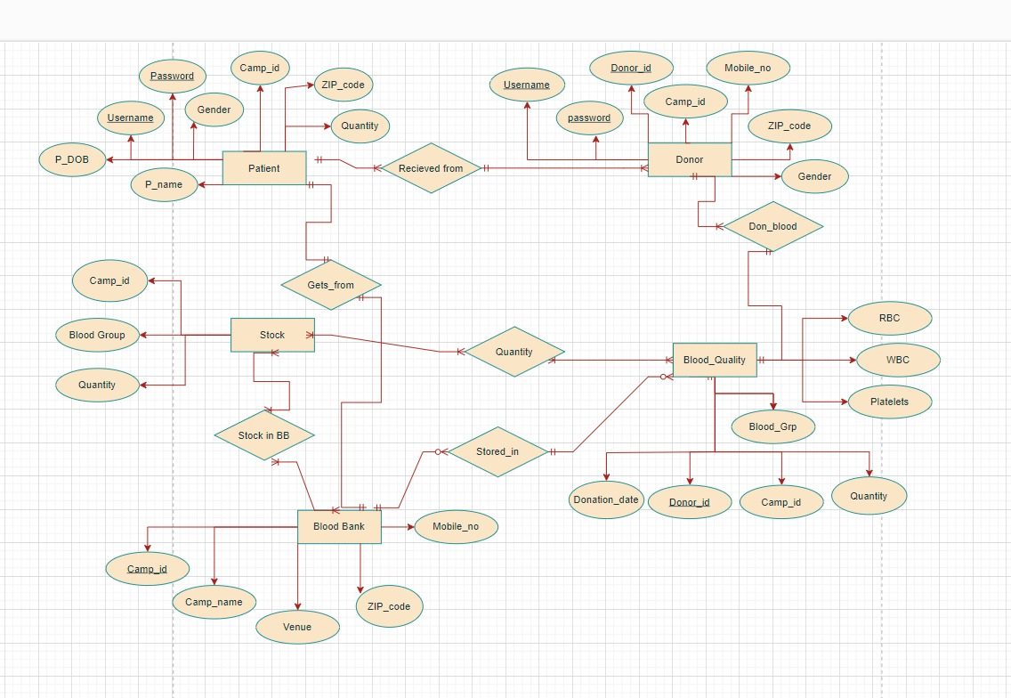

<https://app.diagrams.net/#G12Uk4H8HPTvi2A__8IxY1AcpMCRR34mPf>

Schemas

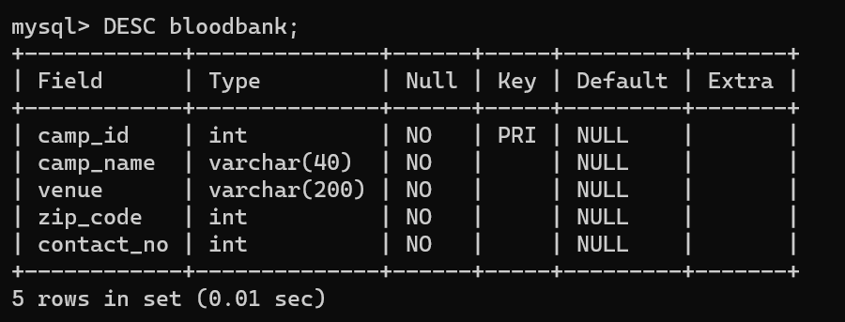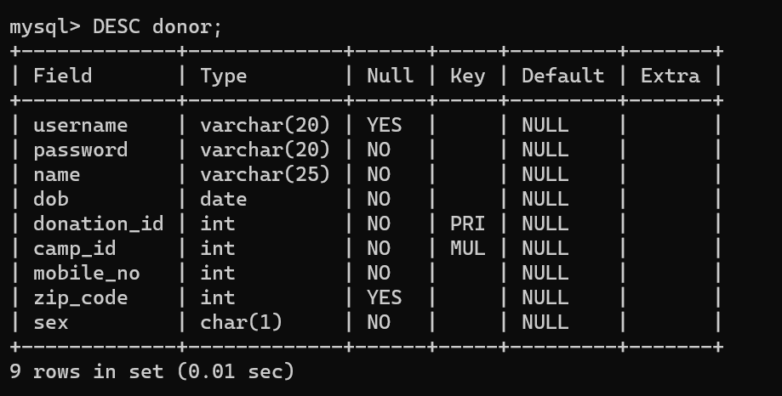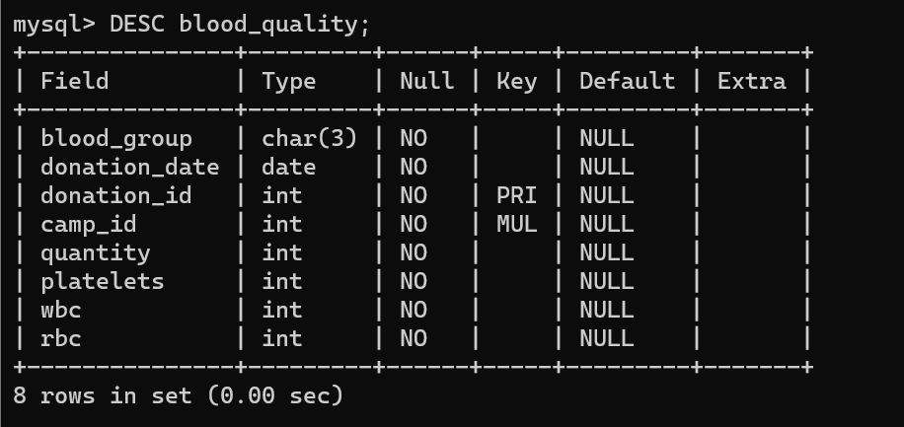

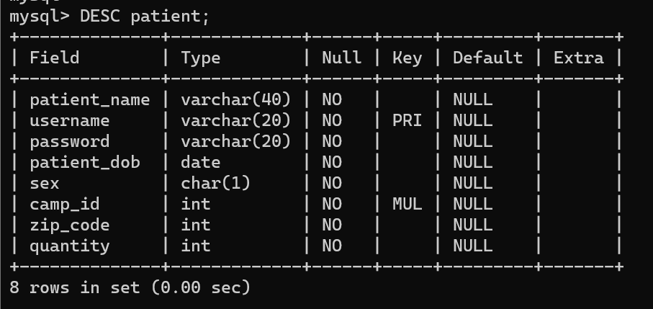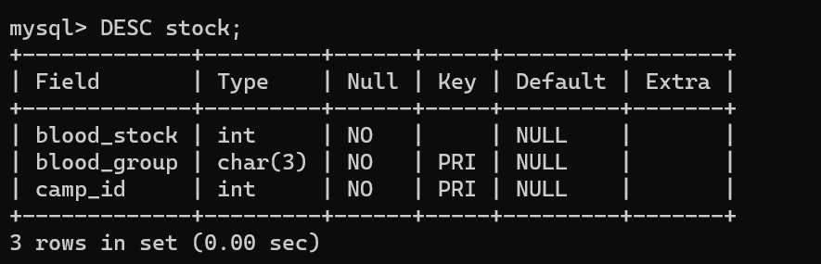

Normalization

**Normalization is divided into the following normal forms:**

1. First Normal Form

2. Second Normal Form

3. Third Normal Form

First Normal Form (1NF)

**For a table to be in the First Normal Form, it should follow the following 4 rules:**

1. It should only have single (atomic) valued attributes/columns.

2. Values stored in a column should be of the same domain

3. All the columns in a table should have unique names.

4. And the order in which data is stored, does not matter.

**Second Normal Form (2NF)**

For a table to be in the Second Normal Form,

1. It should be in the First Normal form.

2. And, it should not have Partial Dependency.

**Third Normal Form (3NF)**

A table is said to be in the Third Normal Form when,

1. It is in the Second Normal form.

2. And, it doesn't have Transitive Dependency.

All the BloodBank database tables are normalised till 3NF.

REQUIREMENTS

Software Requirements: -

Front end: HTML, CSS

1. HTML: HTML is used to create and save web document. E.g., Notepad/Notepad++
2. CSS: (Cascading Style Sheets) Create attractive Layout

Back end: PHP, MySQL

1. PHP: Hypertext Preprocessor (PHP) is a technology that allows software developers to create dynamically generated web pages, in HTML, XML, or other document types, as per client request. PHP is open-source software.
2. MySQL: MySQL is a database, widely used for accessing querying, updating, and managing data in databases.

XAMPP Server for viewing the output.

Hardware Requirements: -

A device with XAMPP Server installed in it.

SQL Query statements

create database bloodBank;

use bloodBank;

create table bloodbank(

camp_id int primary key,

camp_name varchar (40) not null,

venue varchar (200) not null,

zip_code int not null,

contact_no int not null );

create table donor(

username varchar(20) ,

password varchar(20) not null,

name varchar(25) not null,

dob date not null,

donation_id int primary key,

camp_id int not null,

mobile_no int not null,

zip_code int ,

sex char(1) not null ,

foreign key (camp_id) references bloodbank(camp_id) );

create table blood_quality(

blood_group char(3) not null,

donation_date date not null,

donation_id int primary key,

camp_id int not null,

quantity int not null,

platelets int not null,

wbc int not null,

rbc int not null,

foreign key (camp_id) references bloodbank(camp_id),

foreign key (donation_id) references donor(donation_id)

#check(wbc >=0) );

create table patient(

patient_name varchar (40) not null,

username varchar (20) primary key,

password varchar (20) not null,

patient_dob date not null,

sex char(1) not null,

camp_id int not null,

zip_code int not null,

quantity int not null,

foreign key (camp_id) references bloodbank(camp_id),

check (quantity between 0 and 5) );

create table stock(

blood_stock int not null,

blood_group char (3),

camp_id int,

primary key (blood_group, camp_id),

foreign key (camp_id) references bloodbank(camp_id),

#check(blood_group in('A+','B+','A-','B-','AB+','AB-','O+',)

check(blood_stock >=0) );

insert into bloodbank values

(101,'Deenanath','Near Sevasadan School',411004,1023456789),

(102,'Sahyadri Hospital','Karve Road',411004,1022456789),

(103,'Sahyadri Hospital','Near Vanaz',4110038,1022245678),

(104,'Ratna Memorial','SB Road',411053,1022224567),

(105,'Sasoon Hospital','Agarka Nagar',411001,1022222678);

INSERT INTO donor values

('gagan_2005','gk2005','Gaganjot Kaur','2005-03-17',1001,101, 123456789, 411031,'F'),

('gagan_2005','gk2005','Gaganjot Kaur','2005-03-17',1002,104, 123456789, 411031,'F'),

('jatin_2004','jp2004', 'Jatin Patil','2004-01-06',1003,102, 123456789, 411014,'M'),

('jatin_2004','jp2004', 'Jatin Patil','2004-01-06',1004,103,123456789, 411014,'M'),

('nimisha_2004','nj2004','Nimisha James','2004-10-15',1005,101, 123456789, 411038,'F'),

('nimisha_2004','nj2004','Nimisha James','2004-10-15',1006,102, 123456789, 411038,'F'),

('nimisha_2004','nj2004','Nimisha James','2004-10-15',1007,102, 123456789, 411038,'F'),

('rujuta_2003','rk2003', 'Rujuta Kulkarni','2003-12-17',1008,104, 123456789, 411004,'F'),

('rujuta_2003','rk2003', 'Rujuta Kulkarni','2003-12-17',1009,105, 123456789, 411004,'F'),

('rujuta_2003','rk2003', 'Rujuta Kulkarni','2003-12-17',1010,105, 123456789, 411004,'F');

INSERT INTO patient VALUES

('Aakansha','aakansha_V','abc1234','2004-11-5','F',101,400615,3),

('Malhar','kore_malhar','def5678','2006-2-3','M',103,400071,1),

('Pranav','dmg_pranav','ghi9012','1998-7-21','M',102,411038,2),

('Rahul','des_rahul','jkl3456','1985-7-11','M',103,400071,2),

('Saanvi','saanvi_r','mno7890','2010-8-9','F',102,411038,3),

('Mahek','tan_mahek','pqr1234','1980-1-30','F',104,400315,4),

('Shreeya','warr_shry','stu5678','1975-5-12','F',105,421022,1),

('Kashish','kashish_shah','vwx9012','2007-12-17','F',101,400615,1),

('Siddhant','Sid_guha','yza3456','2000-4-13','M',104,400315,3),

('Shanaya','V_shanaya','bcd7890','1995-6-5','F',101,400615,3);

SELECT * FROM patient;

INSERT INTO blood_quality VALUES

('AB+','2023-11-15',1001,103,3,170000,4597,5876778),

('O+','2023-11-15',1002,101,2,165200,6566,3876897),

('AB-','2023-11-16',1003,102,2,198245,8687,5778526),

('A+','2023-11-17',1004,101,1,250987,9878,3675879),

('B+','2023-11-17',1005,104,2,290086,10675,6003123),

('O-','2023-11-19',1006,101,1,159720,4473,3860643),

('B-','2023-11-20',1007,105,3,338645,11000,5245635),

('AB+','2023-11-20',1008,103,1,412356,8579,4875640),

('O-','2023-11-21',1009,104,1,449082,9898,5436298),

('B+','2023-11-21',1010,105,2,218757,5563,3525690);

SELECT * FROM blood_quality;

insert into stock values

(10,'A+',101),

(12,'B+',101),

(8,'AB+',101),

(16,'O+',101),

(2,'O-',101),

(3,'A-',101),

(6,'B-',101),

(1,'AB-',101),

(11,'A+',102),

(9,'B+',102),

(8,'AB+',102),

(10,'O+',102),

(3,'O-',102),

(4,'A-',102),

(5,'B-',102),

(6,'AB-',102),

(12,'A+',103),

(13,'B+',103),

(14,'AB+',103),

(15,'O+',103),

(16,'O-',103),

(7,'A-',103),

(8,'B-',103),

(9,'AB-',103),

(12,'A+',104),

(12,'B+',104),

(20,'AB+',104),

(5,'O+',104),

(6,'O-',104),

(7,'A-',104),

(8,'B-',104),

(9,'AB-',104),

(14,'A+',105),

(9,'B+',105),

(2,'AB+',105),

(19,'O+',105),

(4,'O-',105),

(2,'A-',105),

(2,'B-',105),

(2,'AB-',105);

SELECT * FROM Stock;

PL/SQL Query Statements

DELIMITER //

CREATE TRIGGER increment_stock AFTER INSERT ON donor

FOR EACH ROW

BEGIN

UPDATE stock

SET blood_stock = blood_stock + 1

WHERE blood_group = (SELECT blood_group FROM blood_quality WHERE donation_id = NEW.donation_id);

END //

DELIMITER ;

DELIMITER //

CREATE TRIGGER decrement_stock AFTER DELETE ON donor

FOR EACH ROW

BEGIN

UPDATE stock

SET blood_stock = blood_stock - 1

WHERE blood_group = (SELECT blood_group FROM blood_quality WHERE donation_id = OLD.donation_id);

END //

DELIMITER ;

USER INTERFACE DESIGN

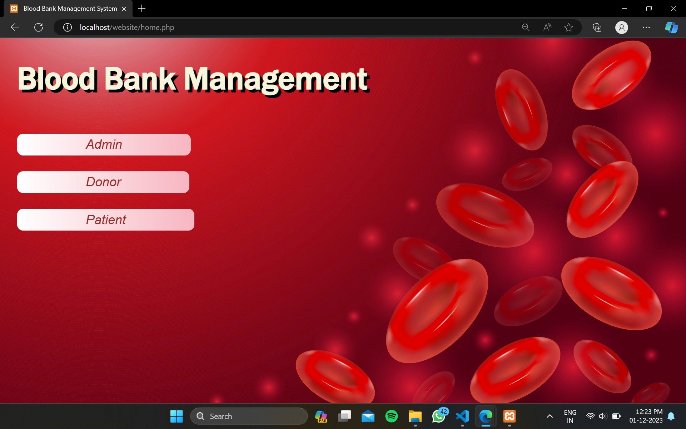

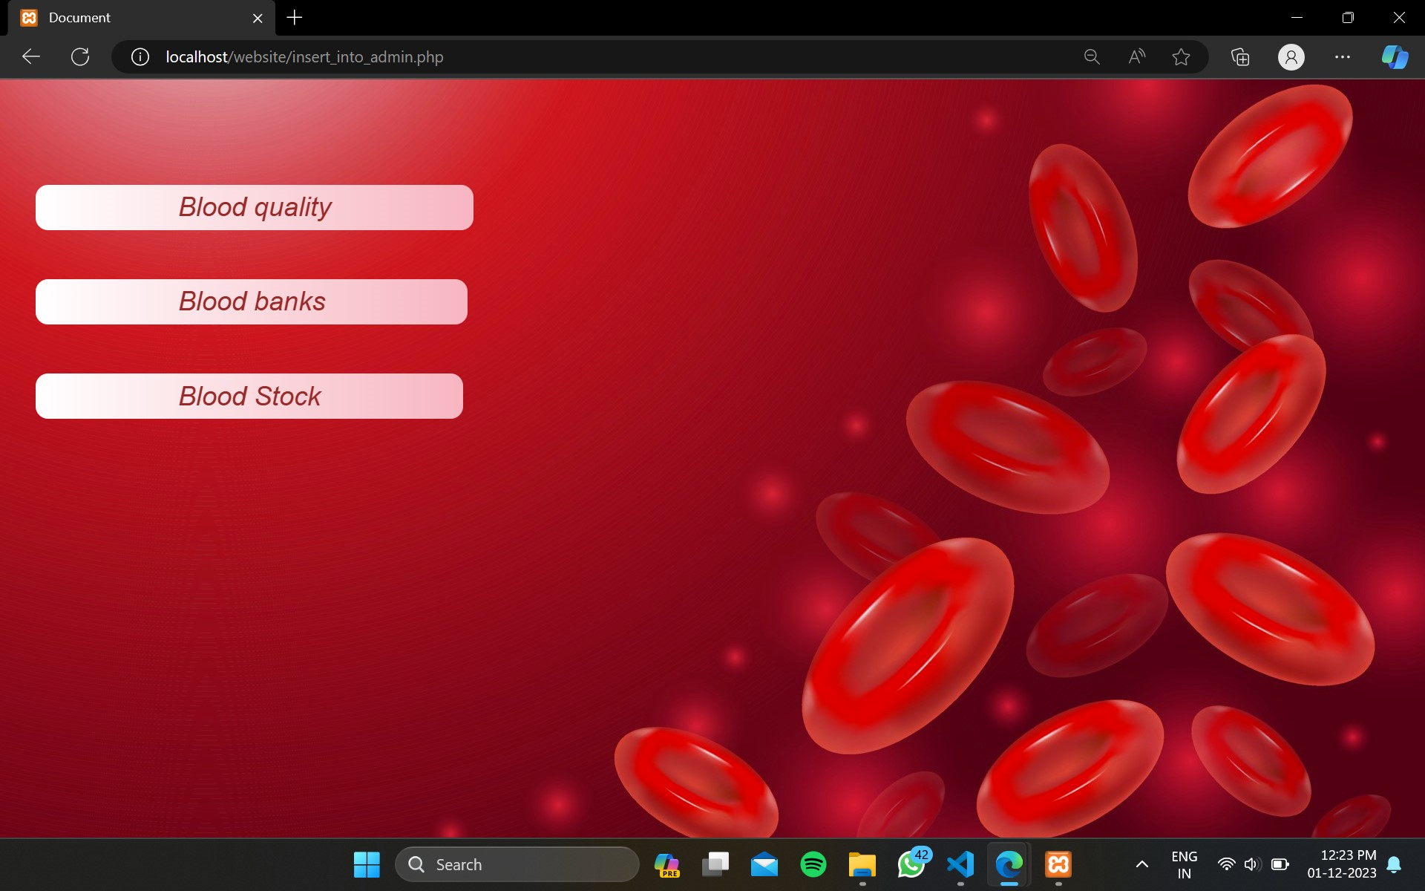

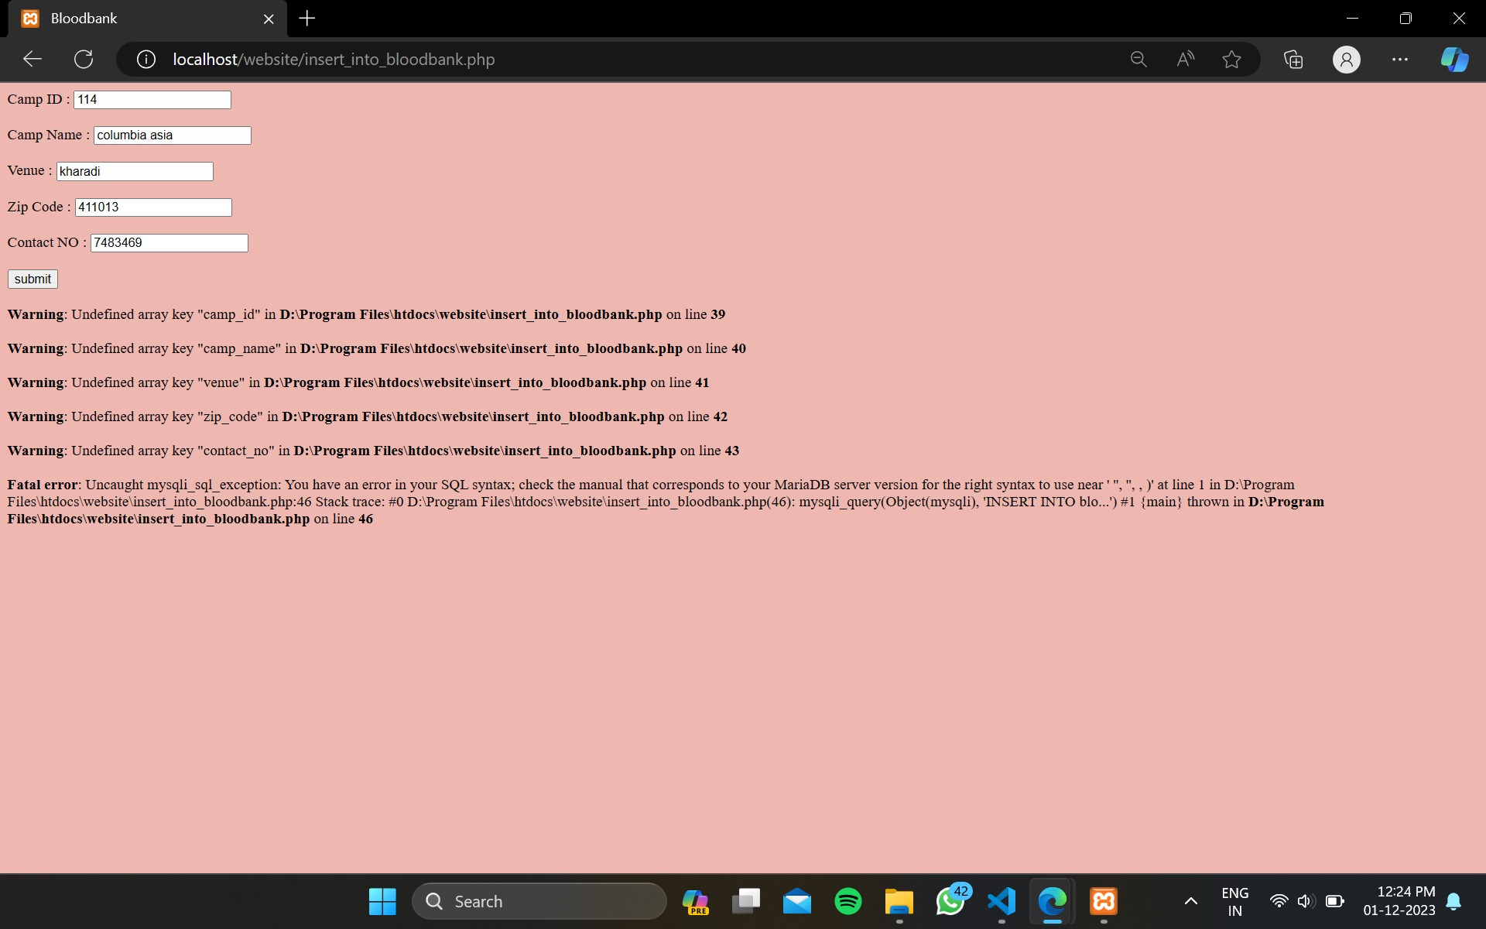

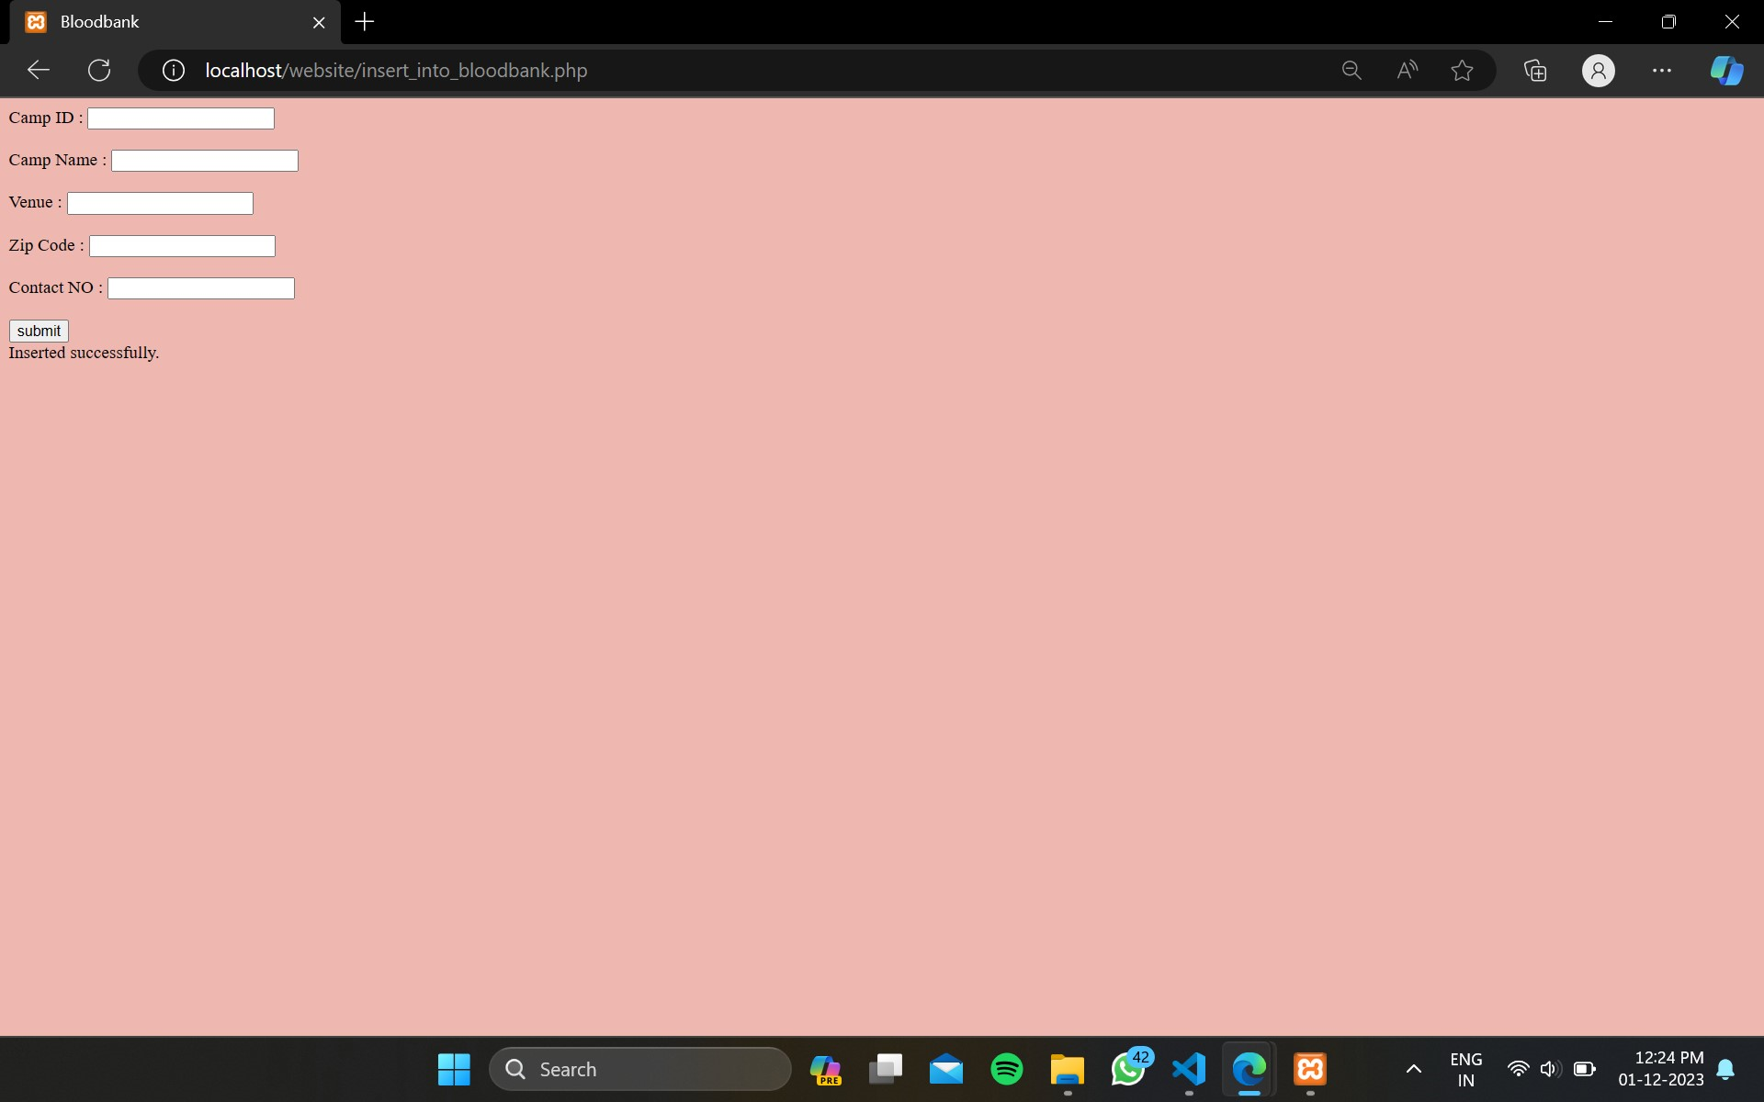

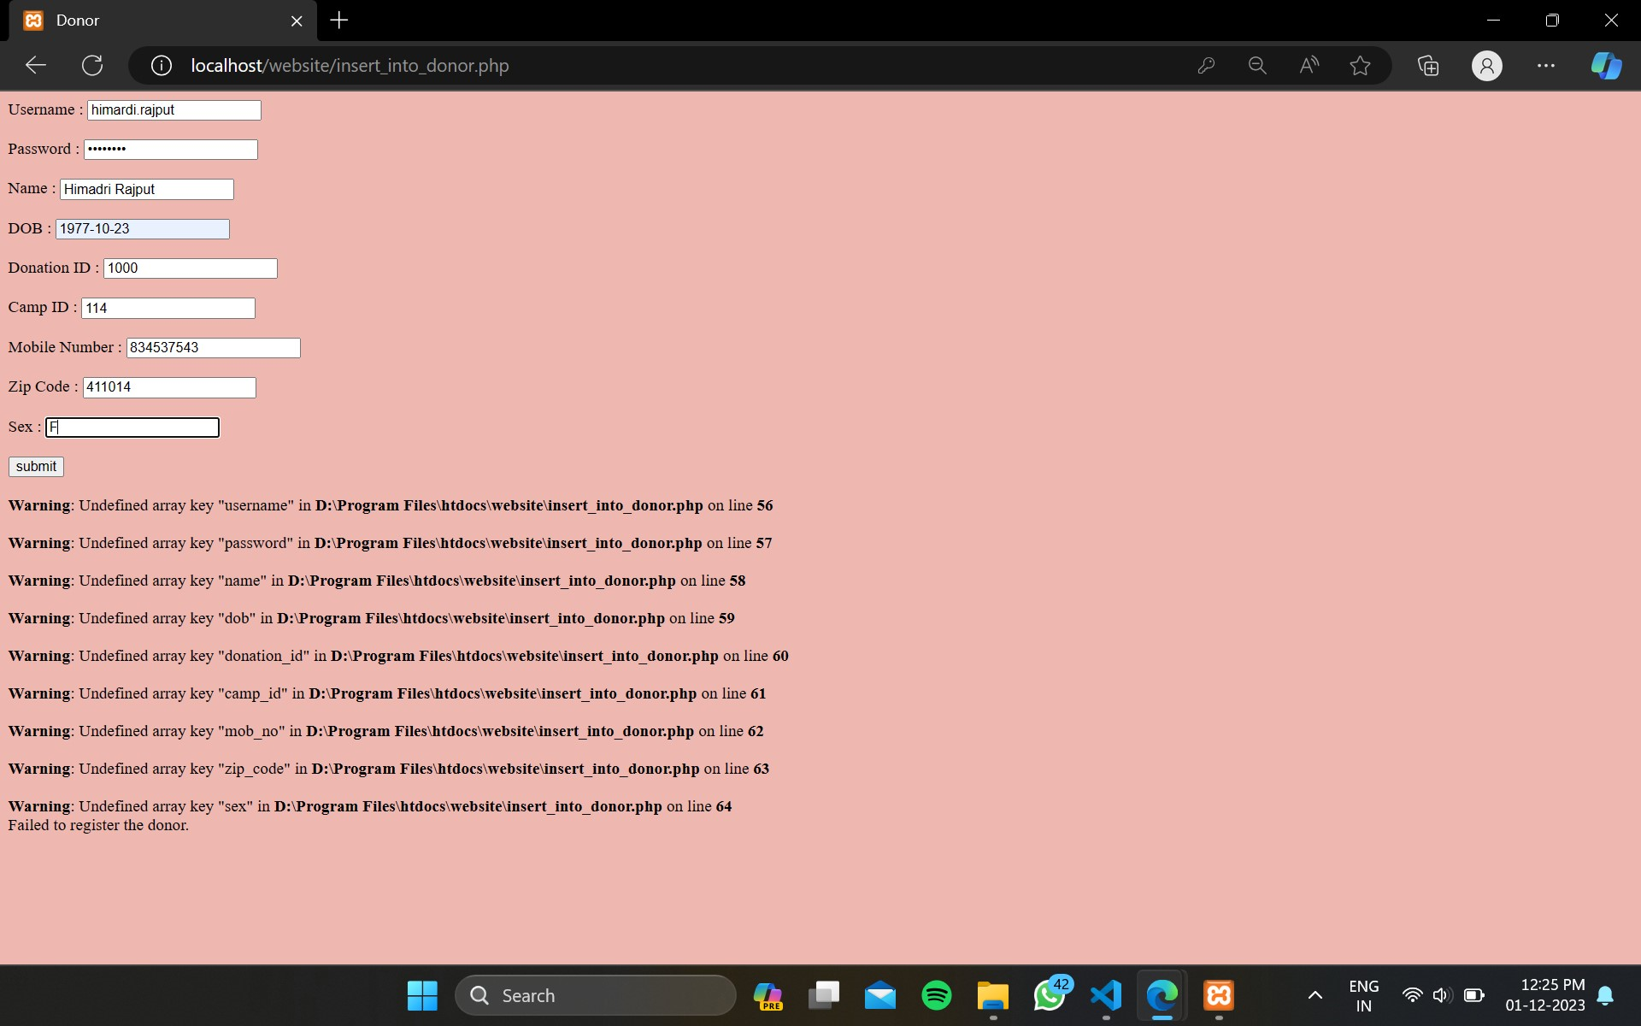

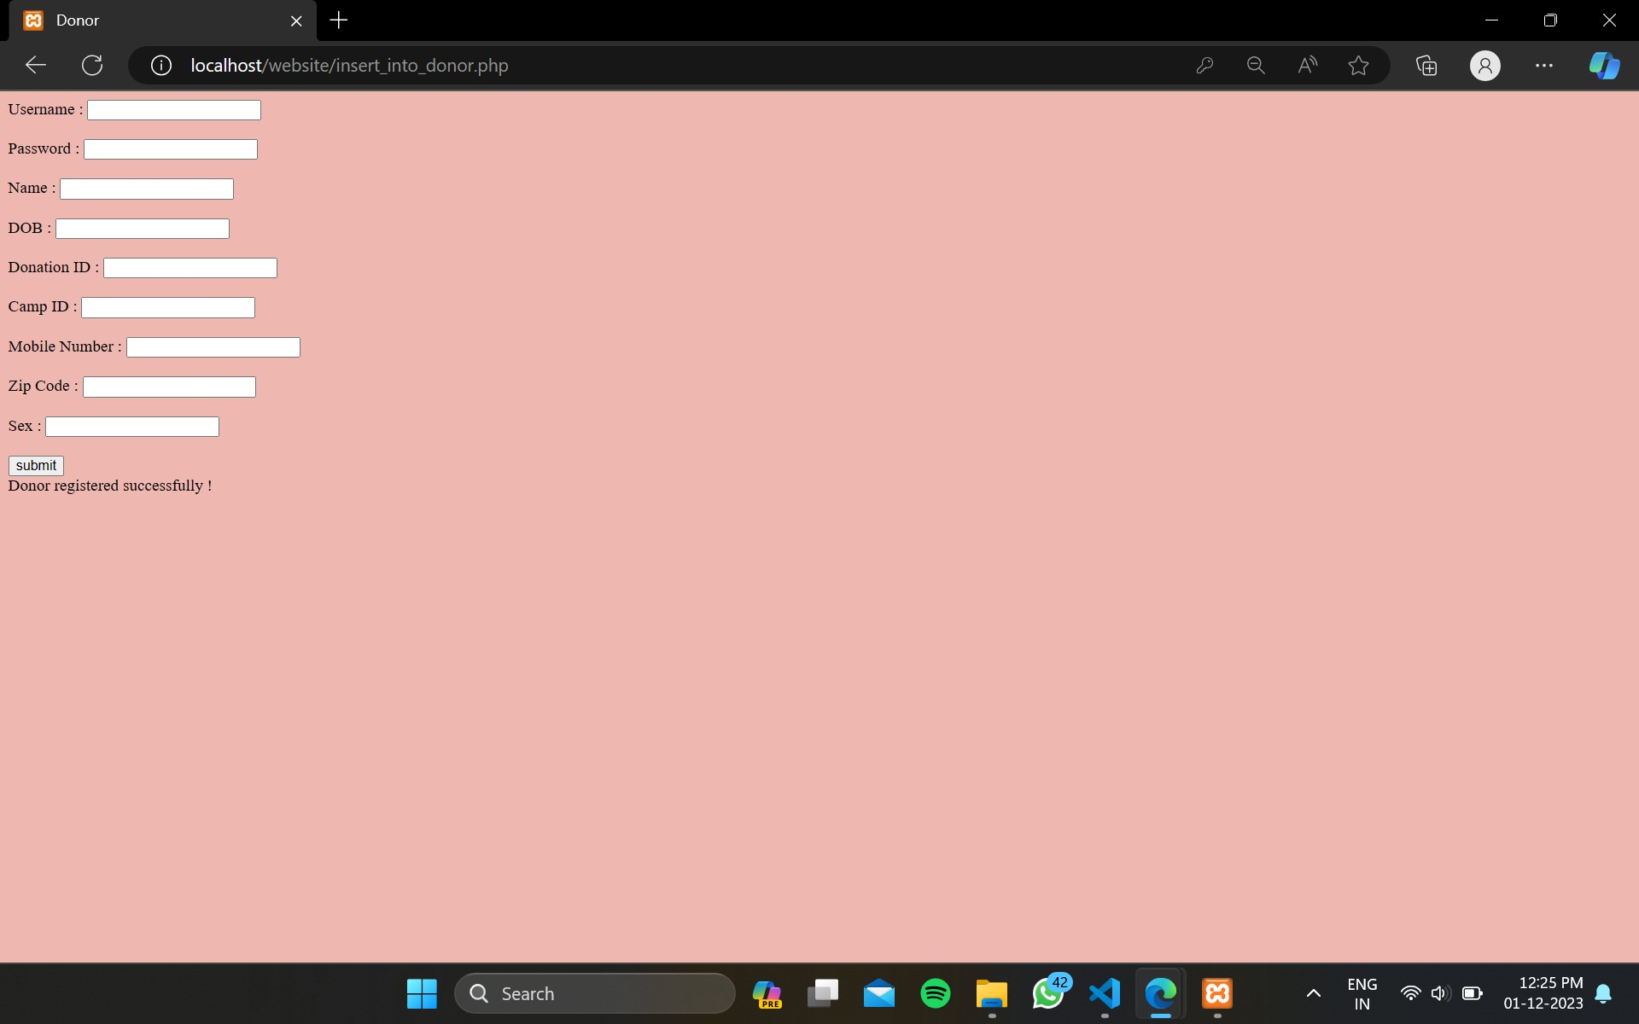

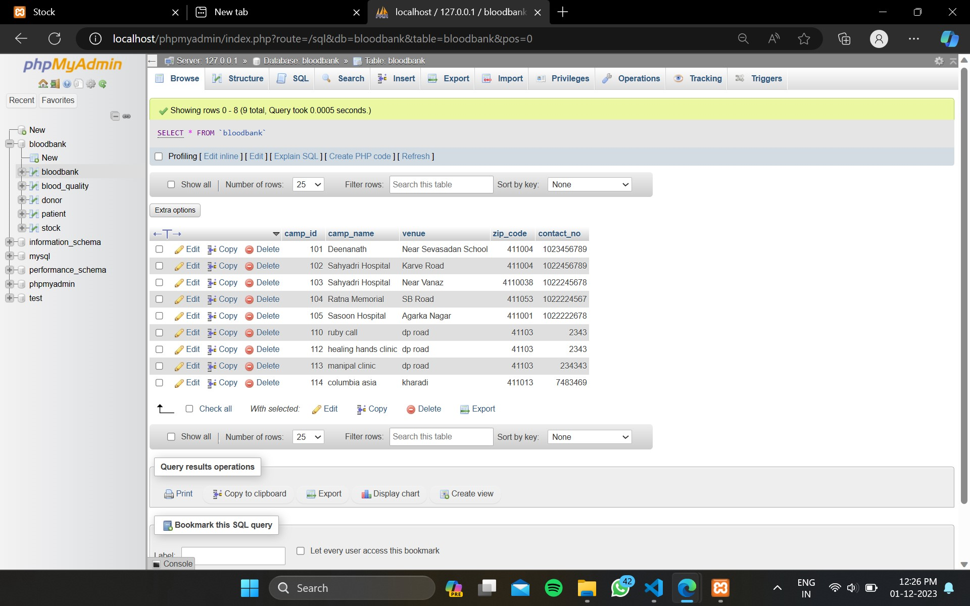

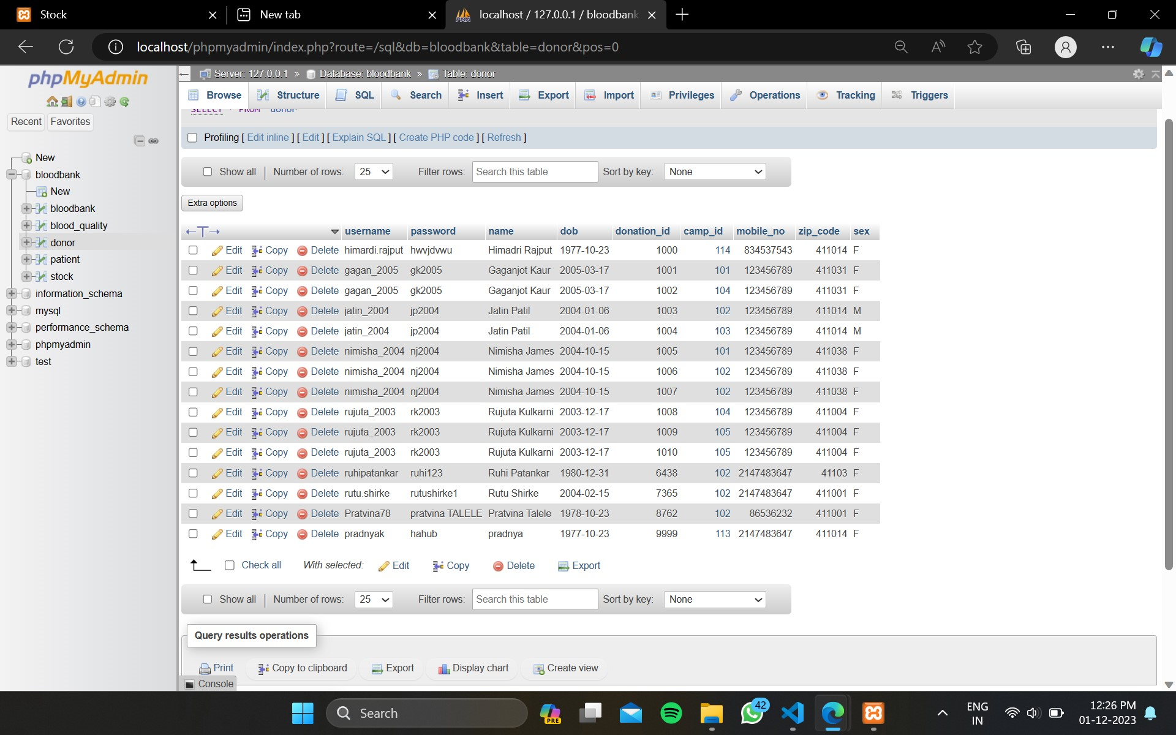

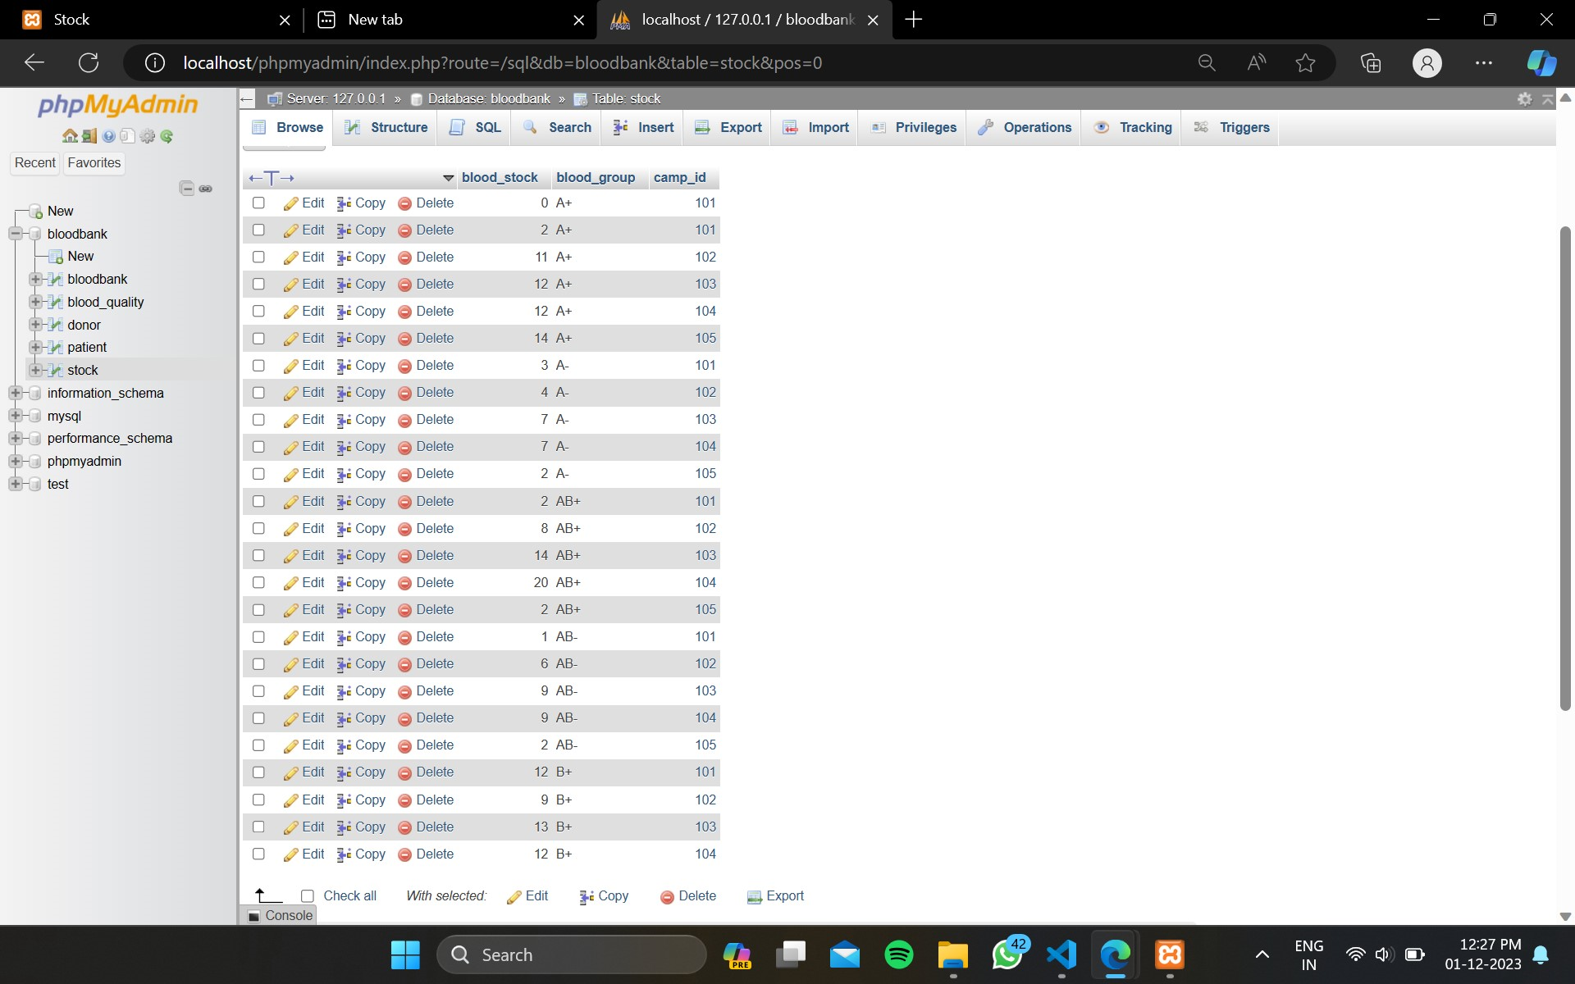

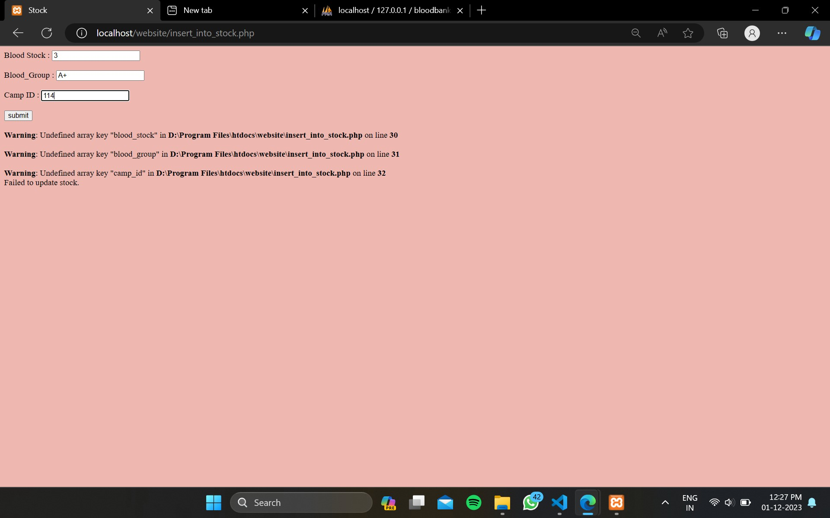

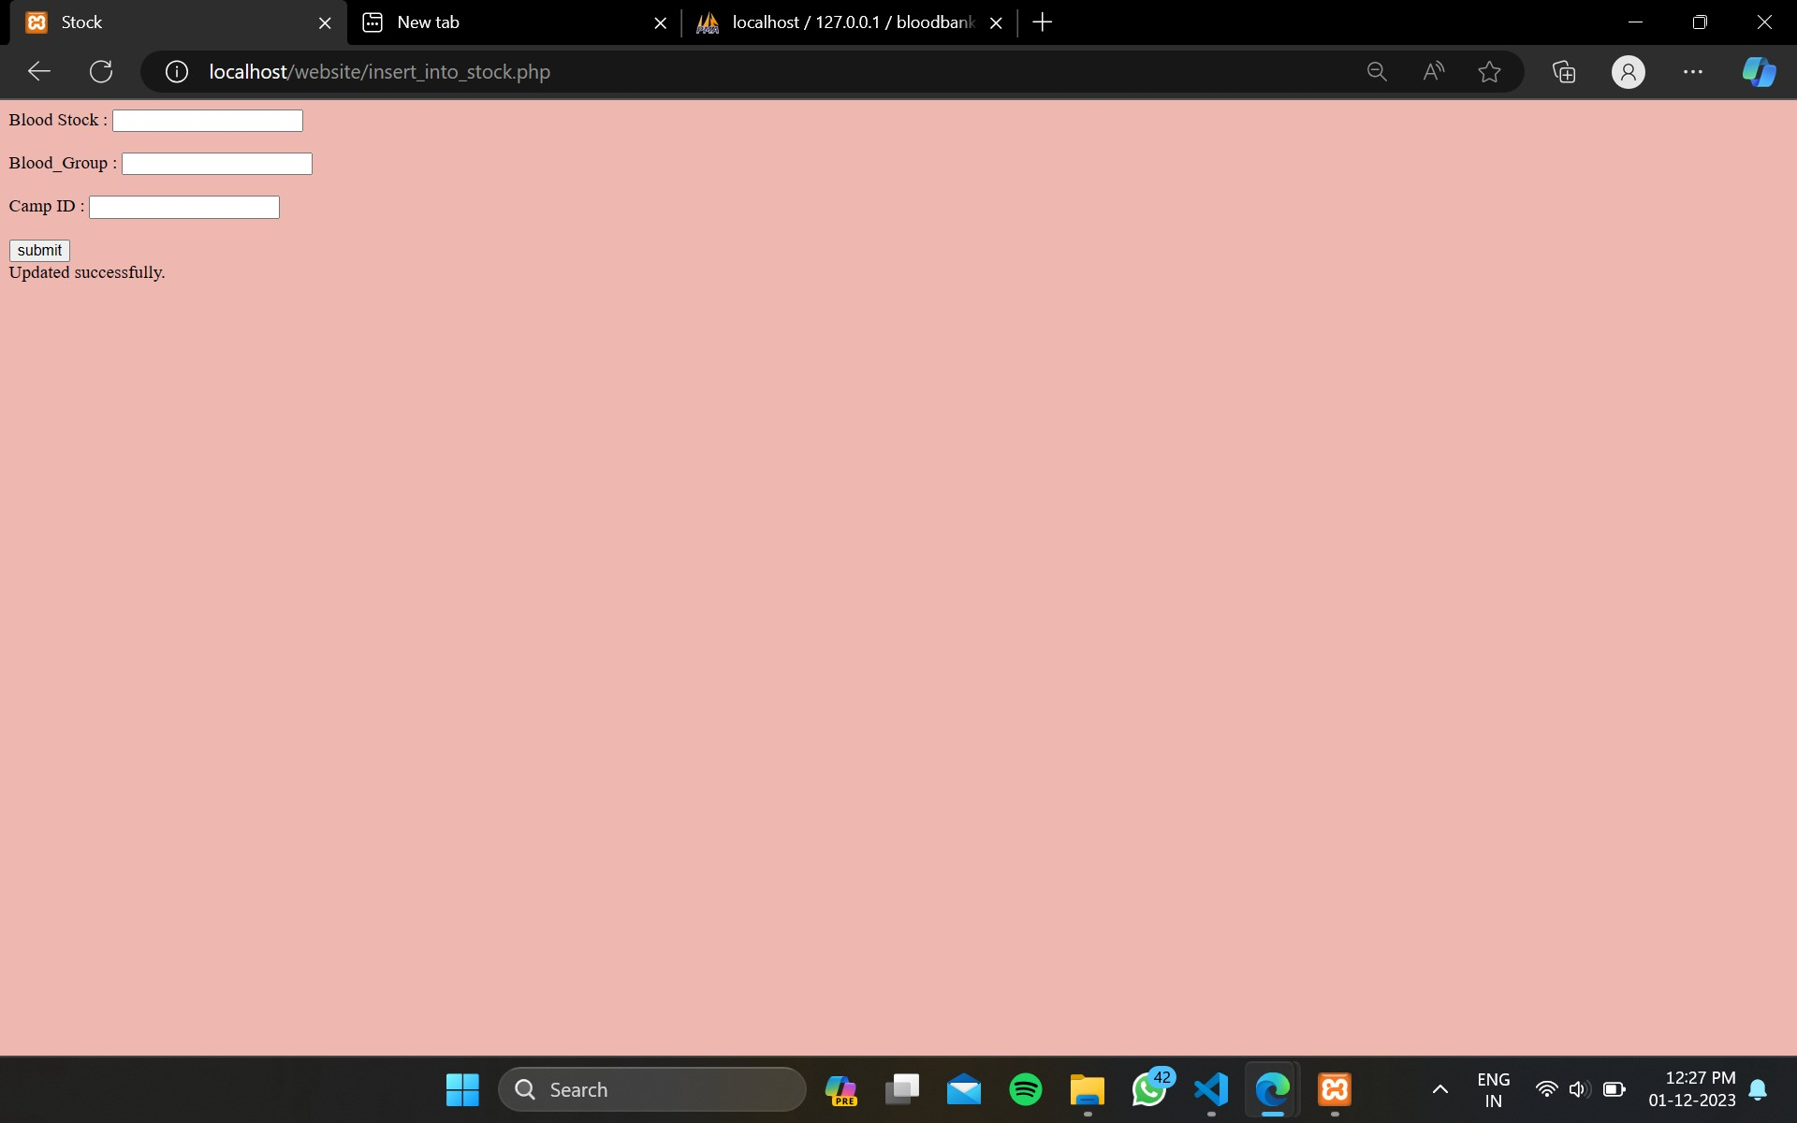

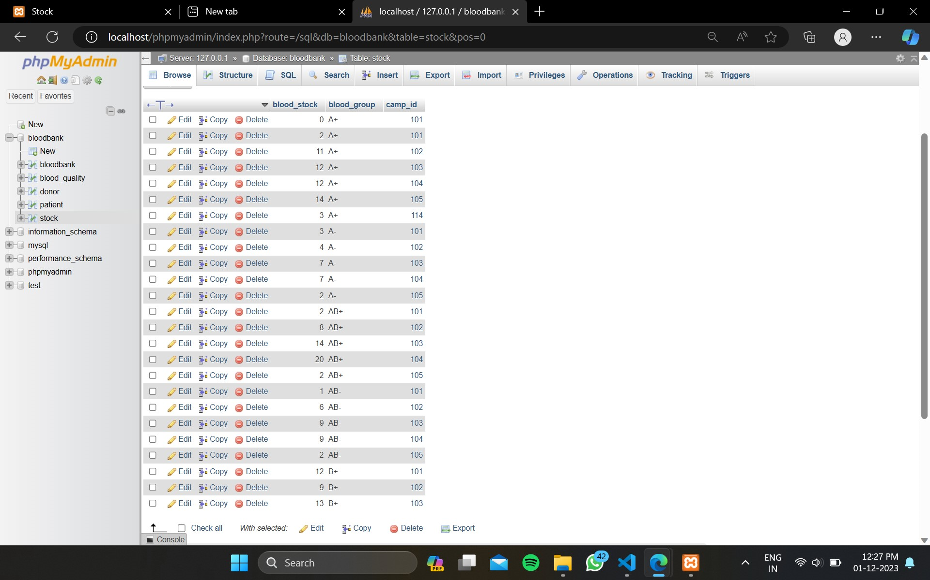

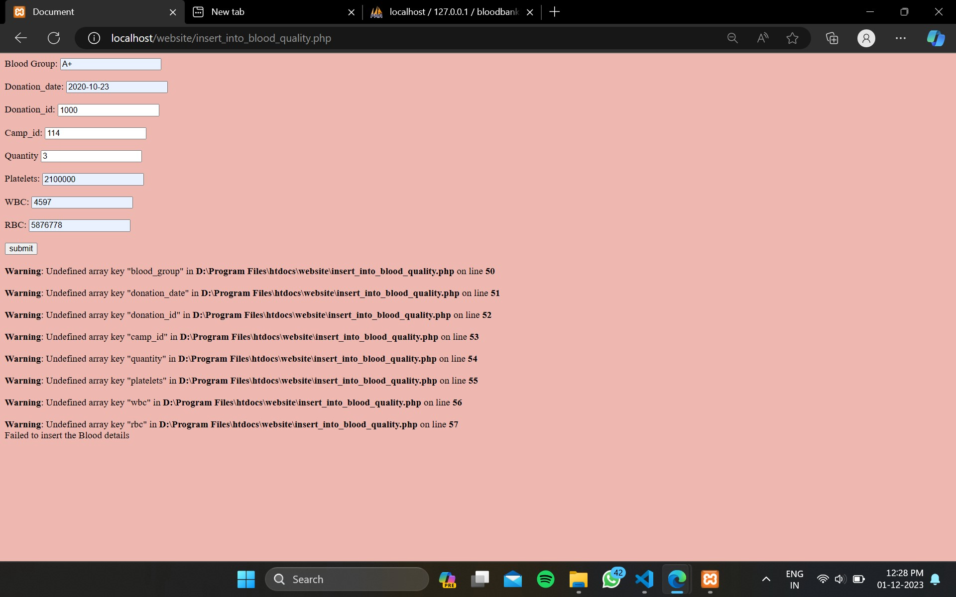

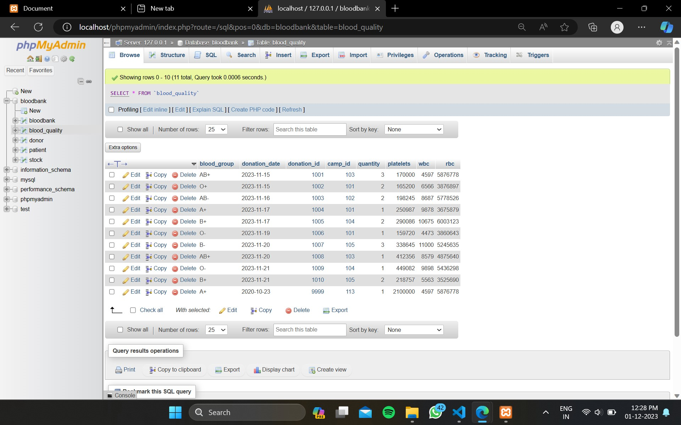

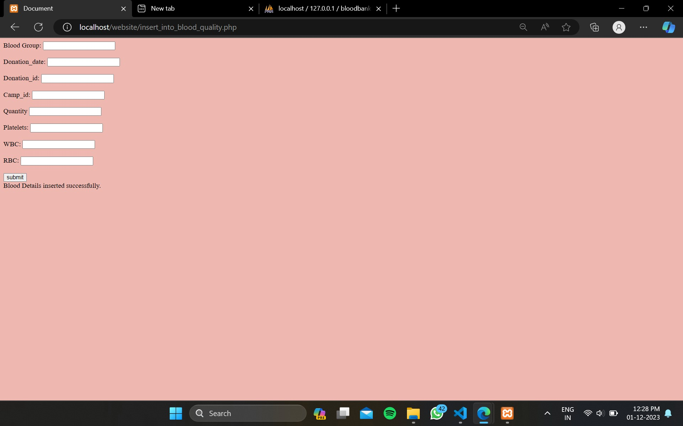

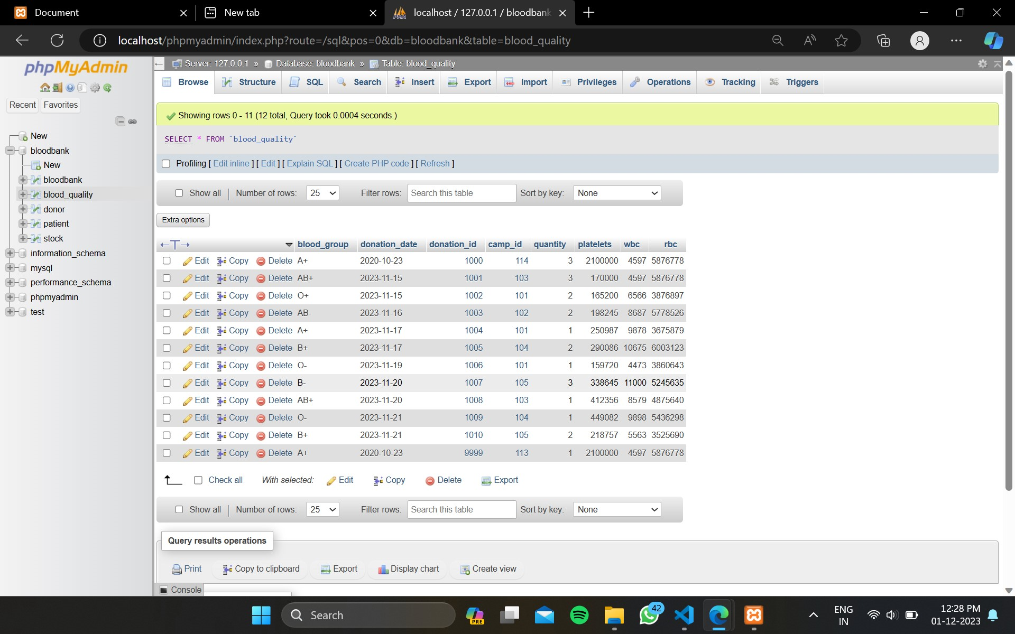

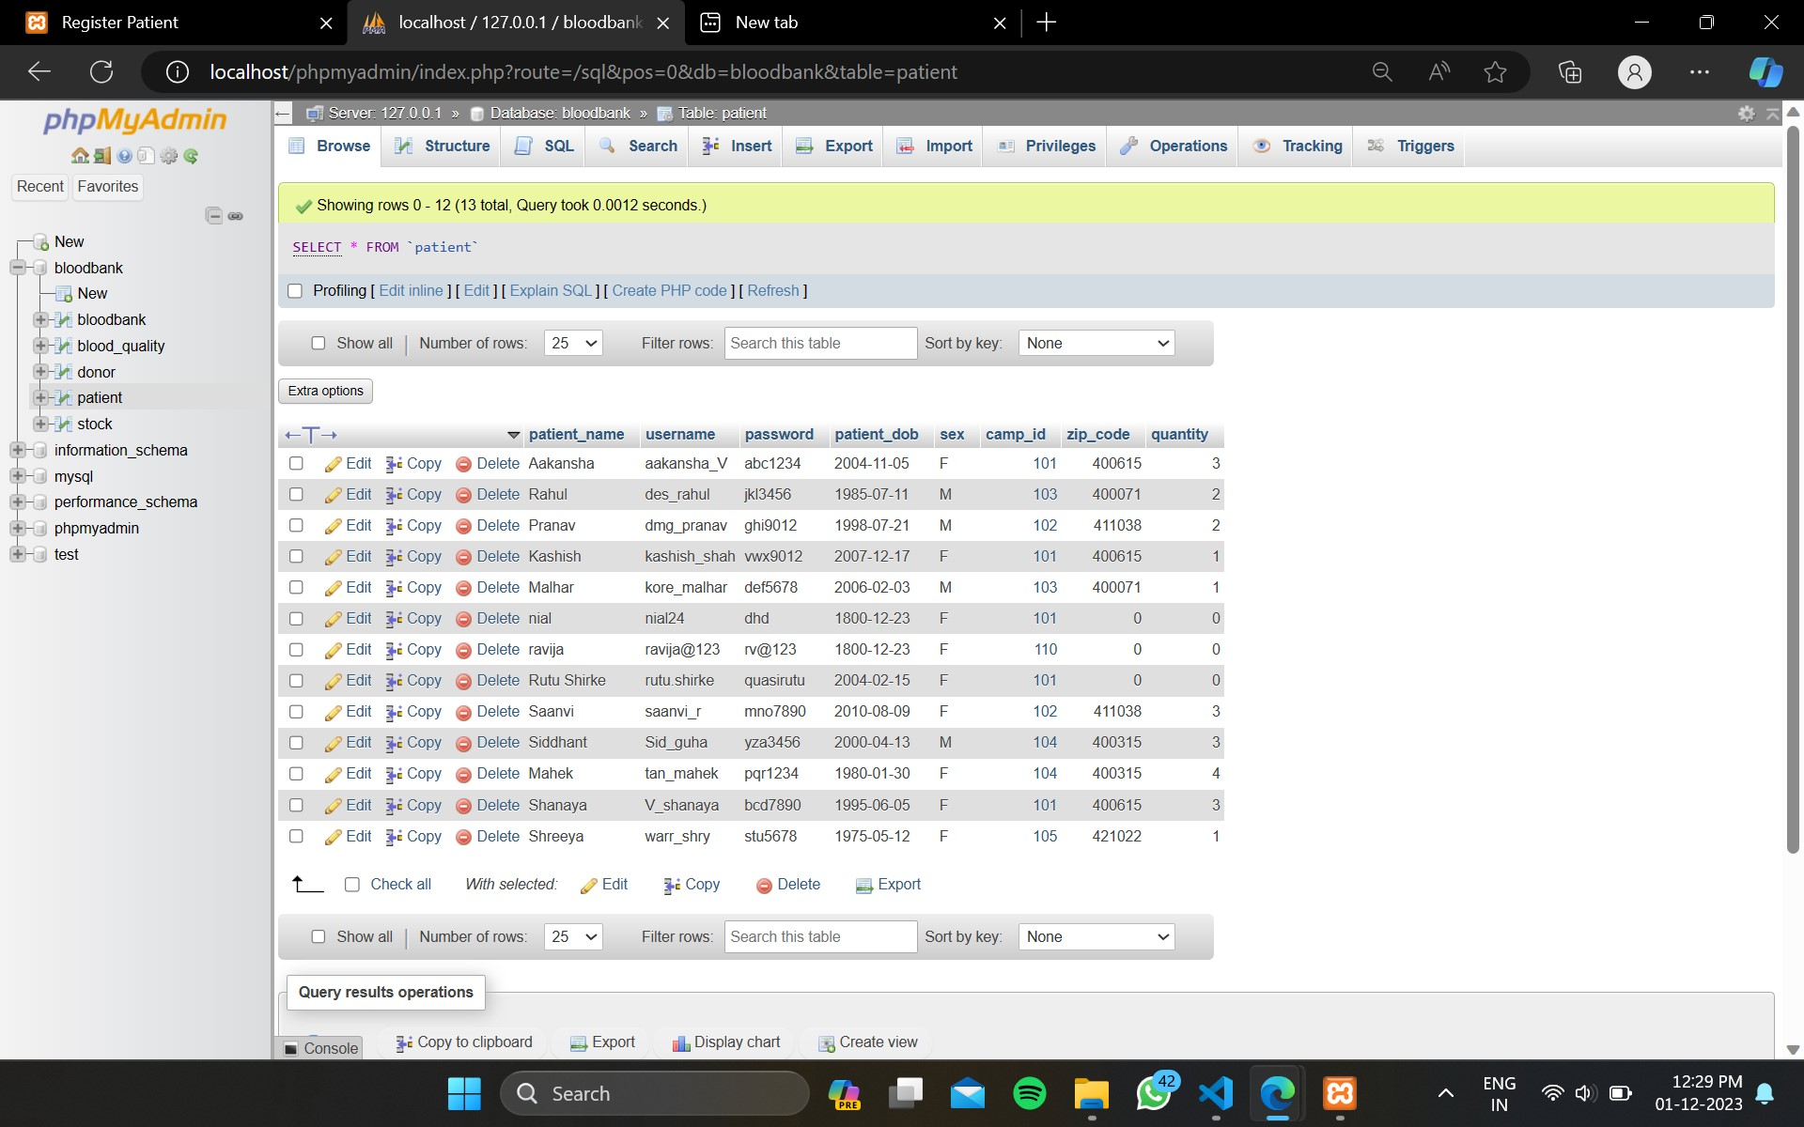

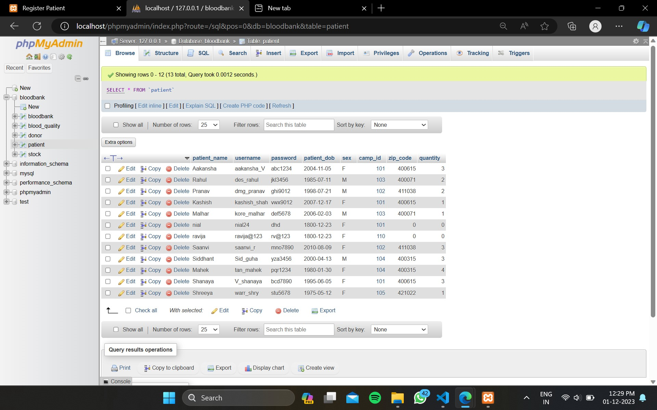

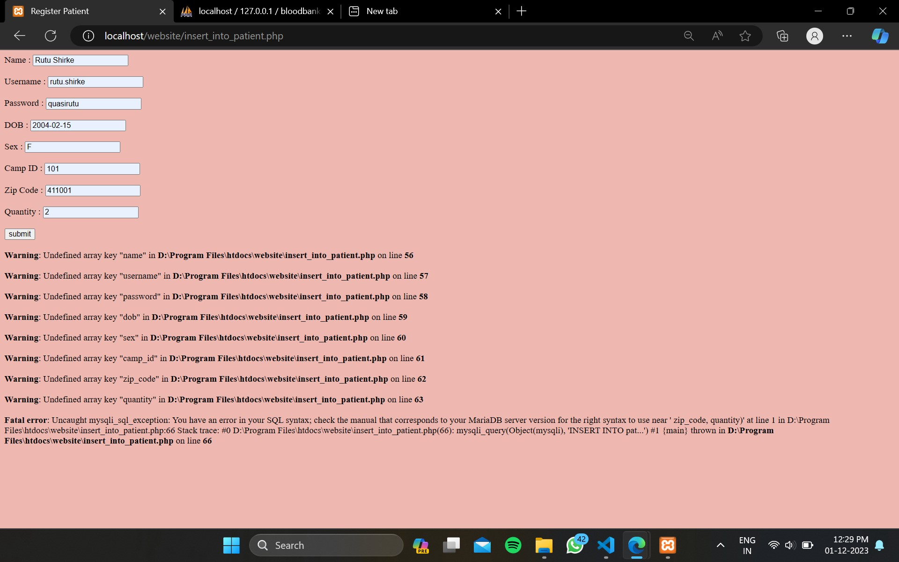

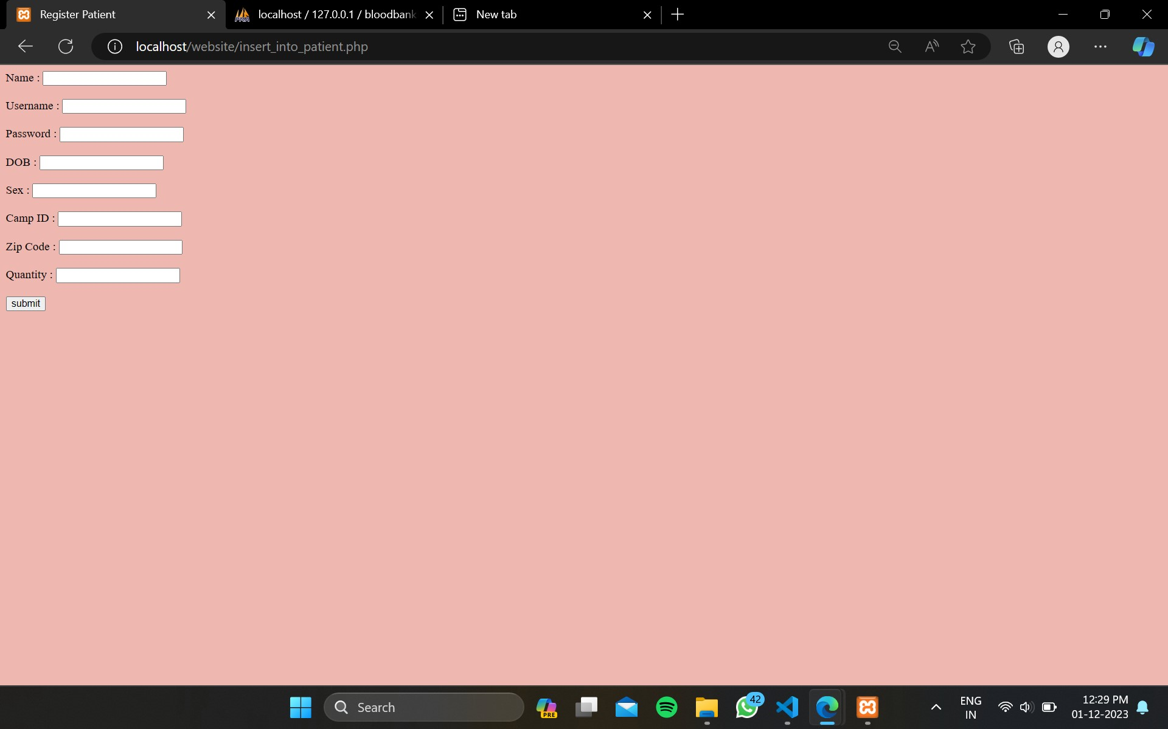

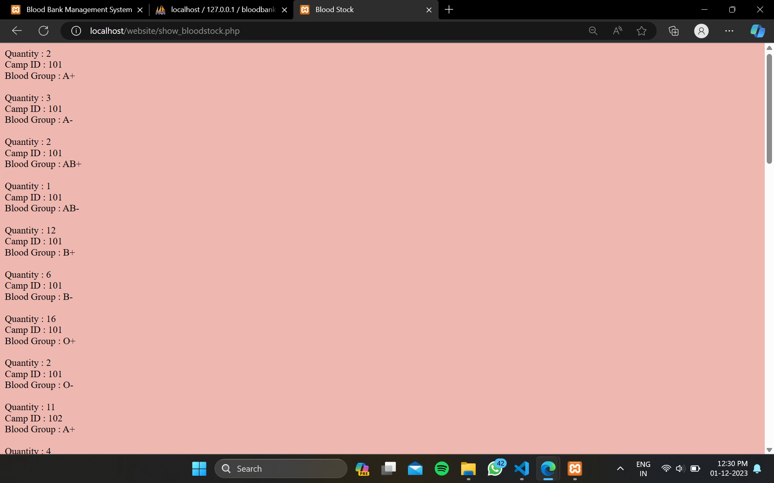

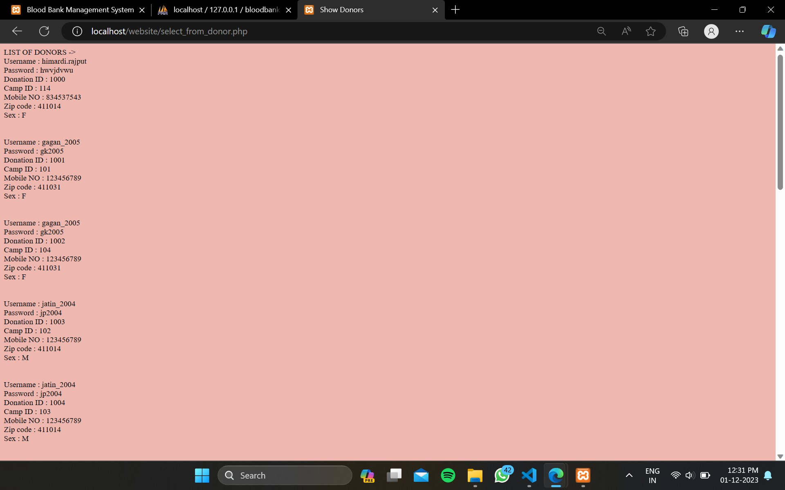

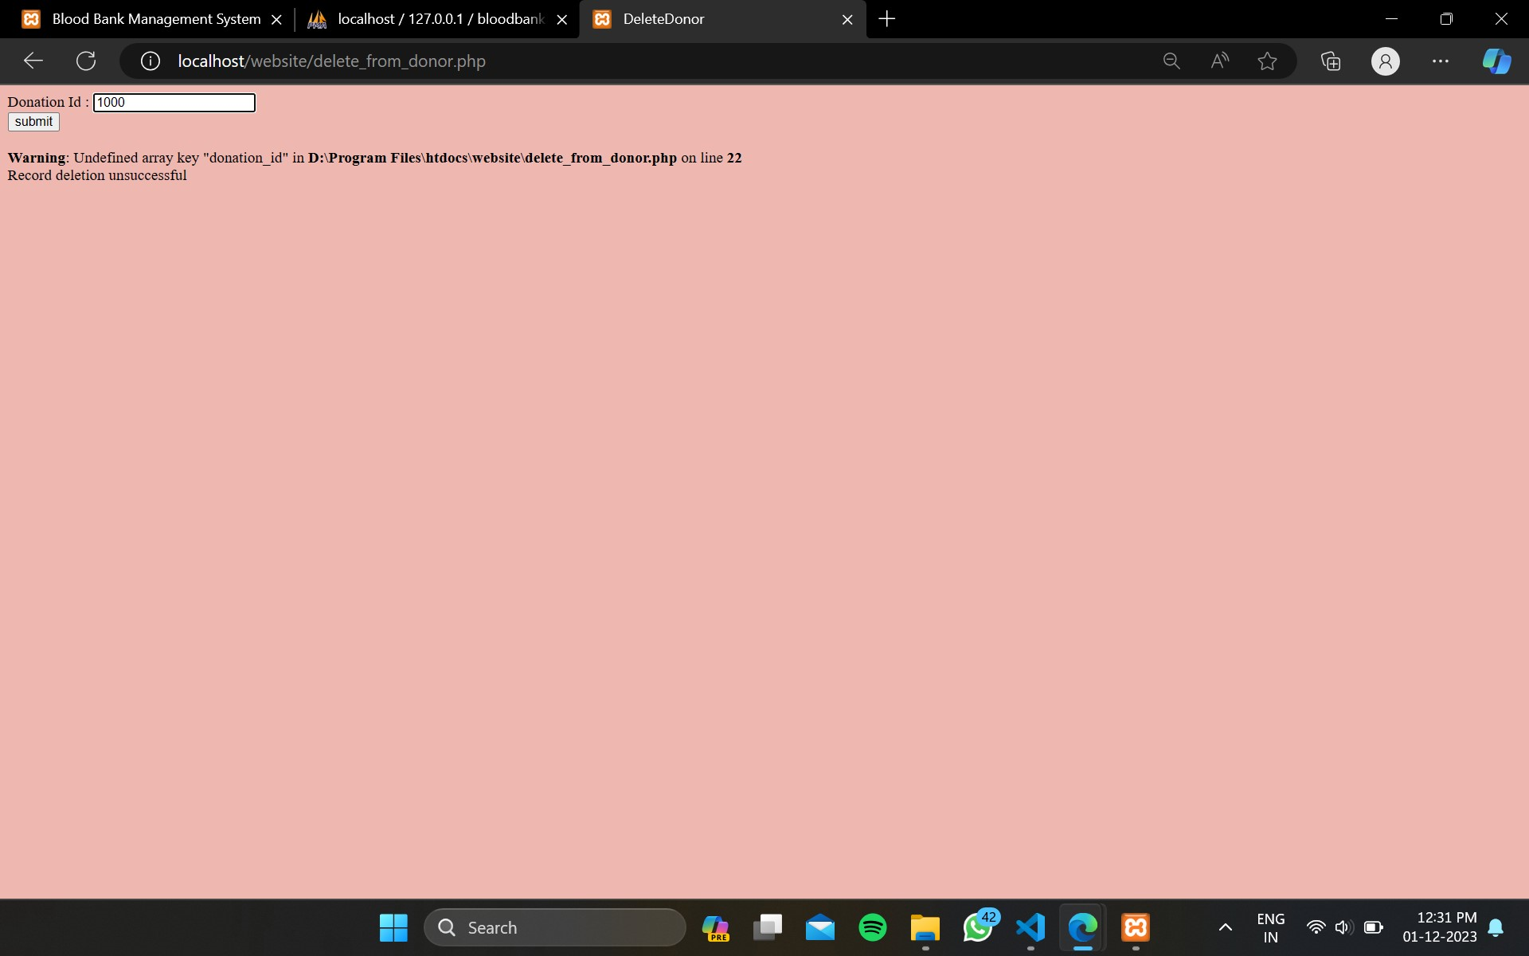



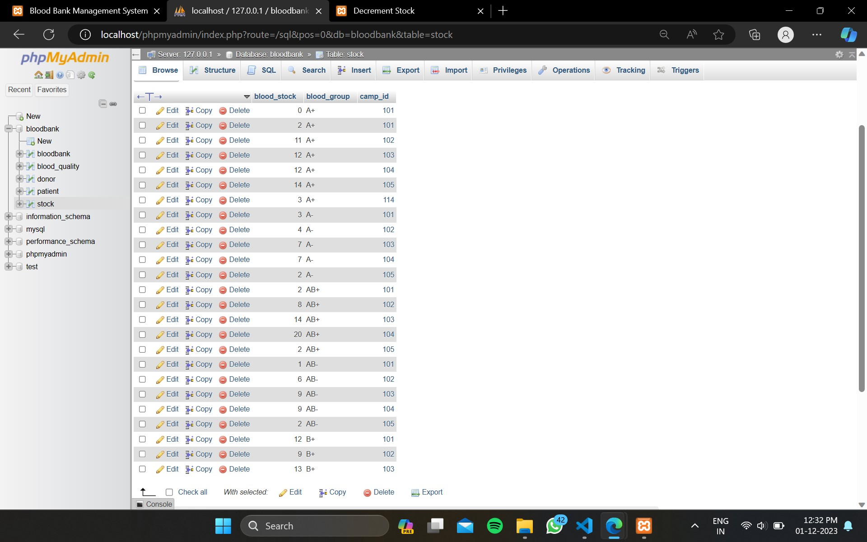

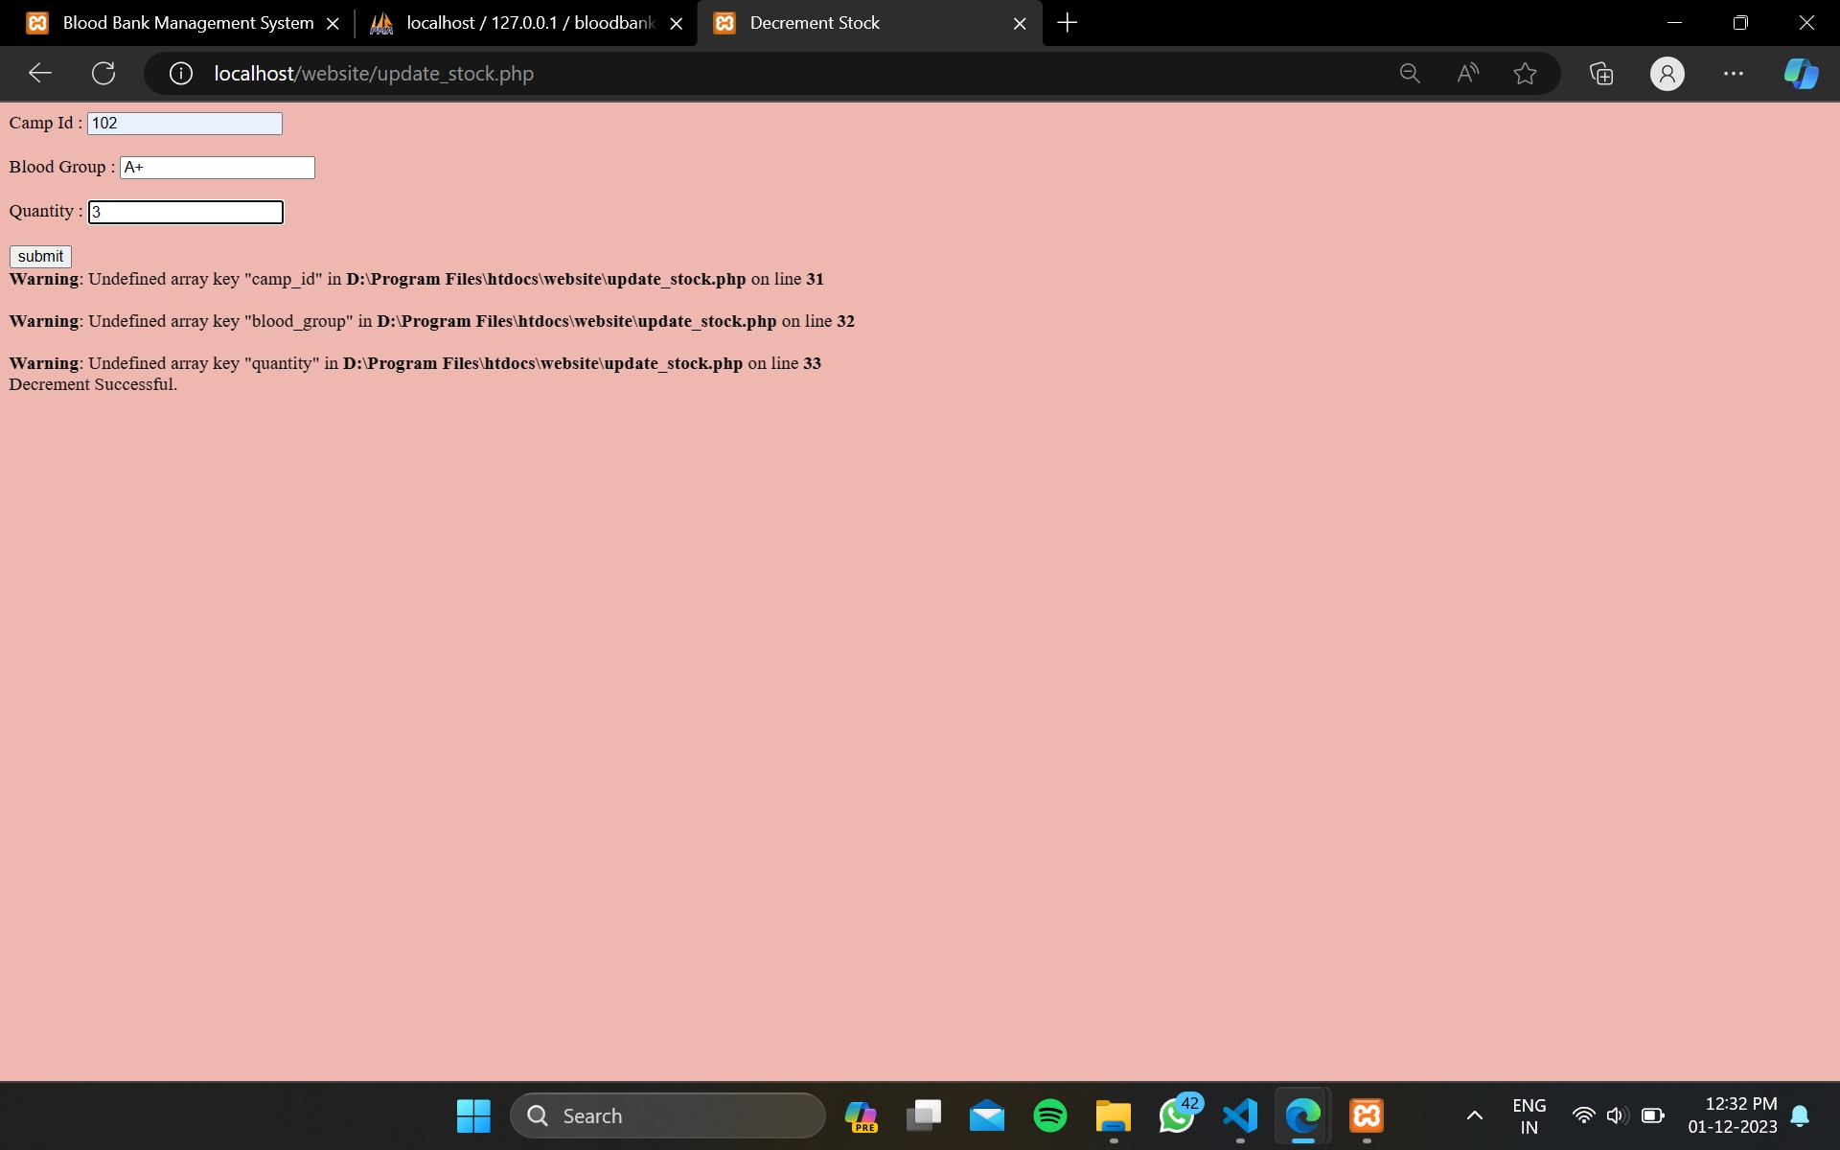

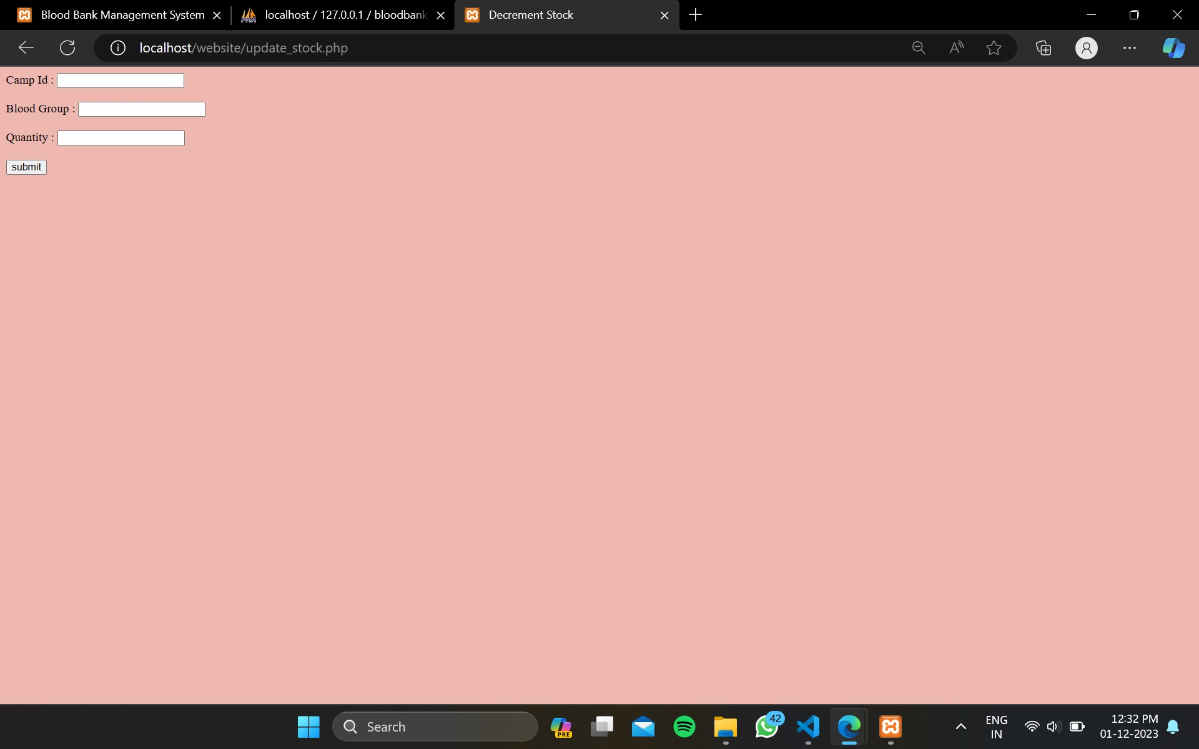

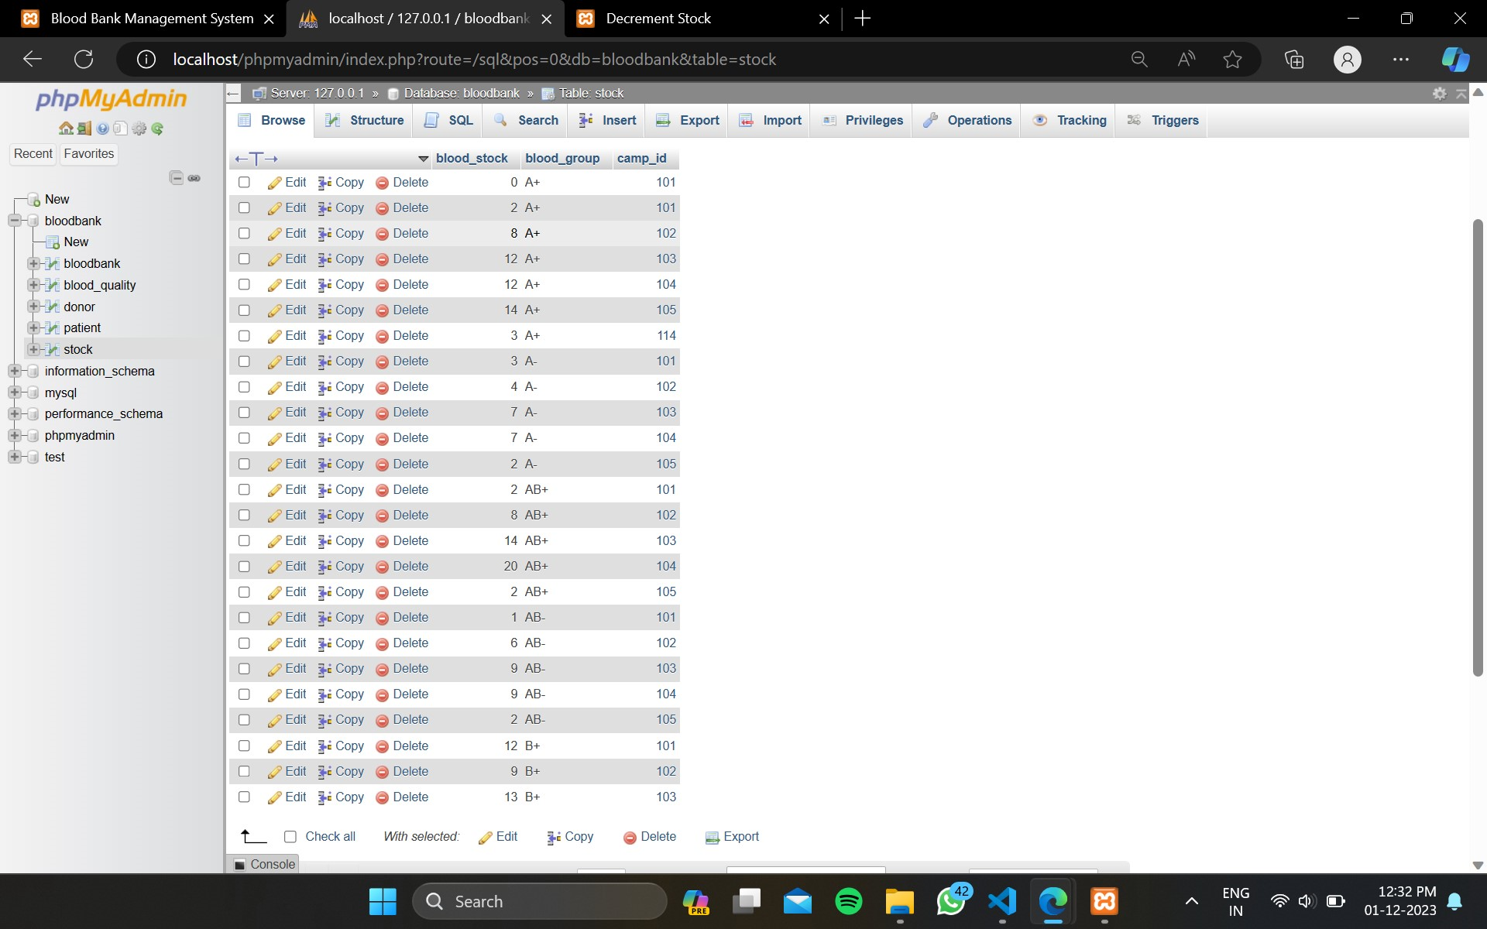

Searching-



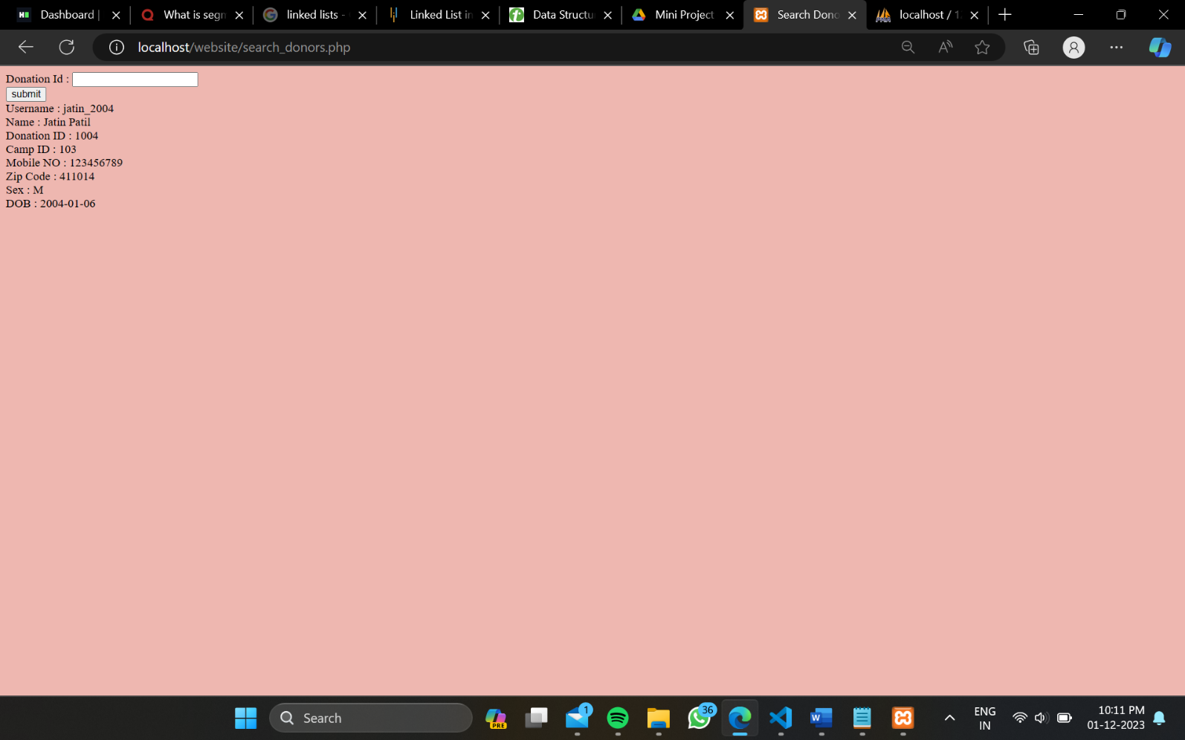

**Conclusion**

The Blood Bank Database Management project has been a significant undertaking with the primary objective of enhancing the efficiency and effectiveness of blood bank operations. Throughout the development process, several key aspects have been addressed and achieved:

**1. System Functionality and Features**

The implemented system demonstrates robust functionality with features tailored to the specific needs of a blood bank. From donor registration to inventory management and blood request processing, the database system provides a comprehensive solution for streamlining day-to-day operations.

**2. Data Integrity and Security**

Ensuring the integrity and security of sensitive health data is of utmost importance. The project incorporates robust data validation mechanisms, encryption protocols, and access controls to safeguard patient and donor information. These measures contribute to maintaining compliance with privacy regulations and standards.

**3. User-Friendly Interface**

A user-friendly interface is crucial for the successful adoption of any database management system. The graphical user interface (GUI) designed for this project prioritizes simplicity and intuitiveness, making it accessible to users with varying levels of technical expertise.

In conclusion, the collaborative efforts of the project team have resulted in a functional and scalable database management system tailored to the unique needs of a blood bank. As we reflect on the achievements of this project, we look forward to its positive impact on healthcare delivery and the potential for continued innovation in the field.